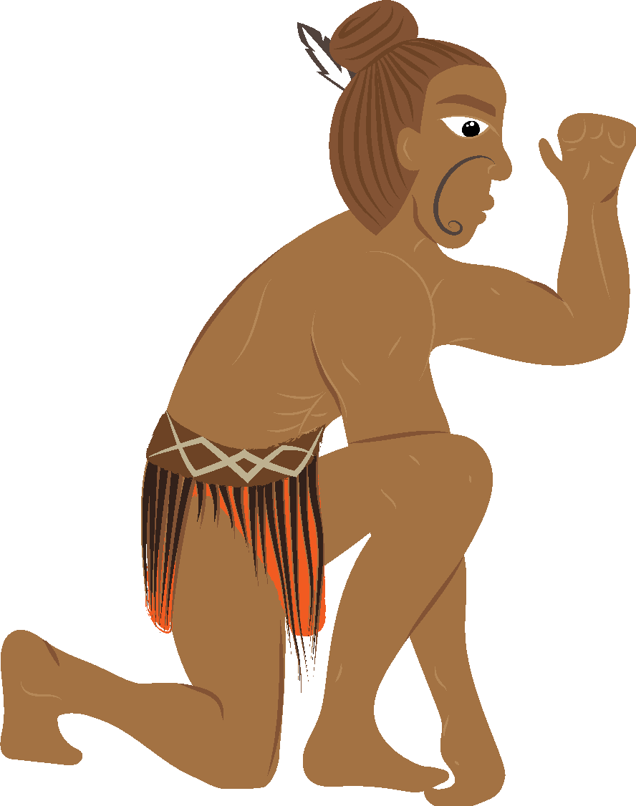

Māui Mataara Te Aromatawai Whakawhanake o te Inihua
Te pare ki tērā kāore e mōhiotia
I tēnei ngohe mā ngā ākonga e tūhura;
- Ngā pūrākau mō Māui me ngā pānga o ēnei ki te inihua
- Te tātai i te utu o te whai inihua, ki tō te kore whai inihua
Ngohe 1:
I āta tutuki i a Māui ōna whāinga. Nāna te tangata i āwhina ki te whakahaere i te ahi, nāna i whakanui ngā haora o te awatea nā te whakapōturi i a Tamanuiterā, ā, nā tana hī ake i Te Ika-a-Māui i whakarato whenua e tupu ai, e puāwai ai ana uri.
Me kī, he momo haumi aua mahi ki te tangata, otirā ka whakarato anō hoki i tētahi momo parenga, ā, koirā te tino tikanga o te inihua.
Nā te tūrama me te wera o te ahi i parea ai te tangata, nā te whakapōturi i a Tamanuiterā kua nui ake ngā haora awatea, ā, nā te hīnga ake i Te Ika-a-Māui i whai whenua ai ngā uri ki te tipu haere tonu me te puāwai.
I roto i te Tūtohi Pūrākau Māui/Tupuna, whakakīa ia wāhanga me te tīmata ki tētahi mahi hautoa a Māui, a tētahi tupuna rānei, me te kī i te momo haumi tērā pea kua homai ki a koe, ki tō whānau, ki tō hāpu, me ērā atu momo inihua ka tautuhi koe.
Ehara i te mea e tika ana, e hē ana rānei ētahi whakautu.
Mēnā kāore anō kia oti i a koe te wāhanga o ngā Haumi Māui Ātea, ka āhei te hoki mai ki tēnei tūtohi ā muri atu. Kua oti kē te tauira tuatahi mōu.

Tūtohi Pūrākau Māui/Tupuna
Ngā mahi hautoa o  ngā pūrakau Māui,  a tētahi tupuna rānei | Moni haumi | inihua / Parenga
Kahungunu | Nāna te tokomaha o ngā wāhine i moe, me te aha ka whiwhi i te nui o te whenua | Nāna āna uri i pare mā te whakarite kia whai whenua rātou e ora ai rātou.

Ngohe 2:
Tēnā pea kāore koe e whakaaroaro ana mō te inihua i tēnei wā tonu, engari ki te pātai koe i ō mātua, i tētahi whanaunga tata rānei, mēnā kua whai inihua rātou, he āhua pai tēnā kia mārama haere koe ki te uara o te whai inihua ina whakatauritea ki te utu mō
te hoko.
I tēnei ngohe ka uiuitia e koe kia tokotoru ngā tāngata, ko tētahi o te whānau, ko tētahi kaiako, ko tētahi pakeke e piri ai koe, kia kitea he aha ngā momo inihua kei a rātou, me ngā take i hokona ai. Kua hangaia mōu ō pātai uiui. Tuhia ō whakautu ki roto i te Tūtohi Kitenga inihua, ka whakautu ai i tō pātai whakamutunga ki raro i tēnei tūtohi.

Ngā Pātai Uiui
1. Kōrerotia mai te ingoa o tētahi o āu inihua.
2. E hia te tapeke o ngā utu whāngai mō te tau?
3. He aha koe i hoko ia i taua inihua?
Tūtohi Kitenga inihua
 | Momo inihua | He aha i kōwhiri ai koe i taua  momo inihua? | Te maha o ngā utu i te tau
1
2
3

- I muri i te otinga o tēnei uiui, e whakapono ana koe ka raupatuhia te utu i ngā utu inihua i te tau e te parenga e whakarato ana taua momo inihua?
Me whakamārama he aha i pēnā ai ō whakaaro?

____________________________________________________________________________________________________________________________________________________________________________________________________________________________________________________________________________________________________________________________________________________________________________________________________________________________________________________________________________________________________________

Ngā Rauemi Tautoko
https://www.youtube.com/watch?v=IbhuV9xS8vc
http://www.myinsuranceguide.co.nz/insurance-buying-guide/
https://www.aainsurance.co.nz
https://www.stuff.co.nz/business/money/102583868/insurance-woes-excesses-of-anger
https://www.tvnz.co.nz/one-news/new-zealand/why-do-so-few-m-ori-have-any-insurance
https://www.tvnz.co.nz/one-news/new-zealand/tapu-te-ranga-blaze-sheds-spotlight-lack-fire-safety-across-all-marae
https://www.newstalkzb.co.nz/news/national/blaze-that-destroyed-wellingtons-tapu-te-ranga-marae-accidental/
https://www.maoritelevision.com/news/national/high-insurance-premiums-marae
https://www.nzherald.co.nz/wanganui-chronicle/opinion/news/article.cfm?c_id=1503423&objectid=11141493
https://ngatiporou.com/nati-life/marae-life/nati-insure
https://www.stuff.co.nz/dominion-post/news/113843964/fire-alarms-turned-off-before-tapu-te-ranga-blaze

