Māui Ihumanea Te Aromatawai Whakawhanake
mō te Whakatānga

Tatauranga o te uta whakatā, kia pakeke tō haere
He tangata tūpato a Māui Ihumanea, ka whakatakoto mahere e titiro whakamua ana kia hia tau kē ki mua. Nā tana manawanui ki te ako, te whakawhānui ake i te taumata o ana pūkengā, me te hōhonutangā o tana tūāpapa mātaurangā, i āhei ai ia ki te whakaara ake i ēnei whēako mēnā ka hiahia a ia. Koinei te momo mātaurangā ki te whakamahere penapena whakatā.
I roto i tēnei ngohe, ka:
- mārama ki te nui o te piki me te heke o ngā tākoha i te wā e mahi tonu ana ia
- ako ki te whikawhika mahere penapena whakatā

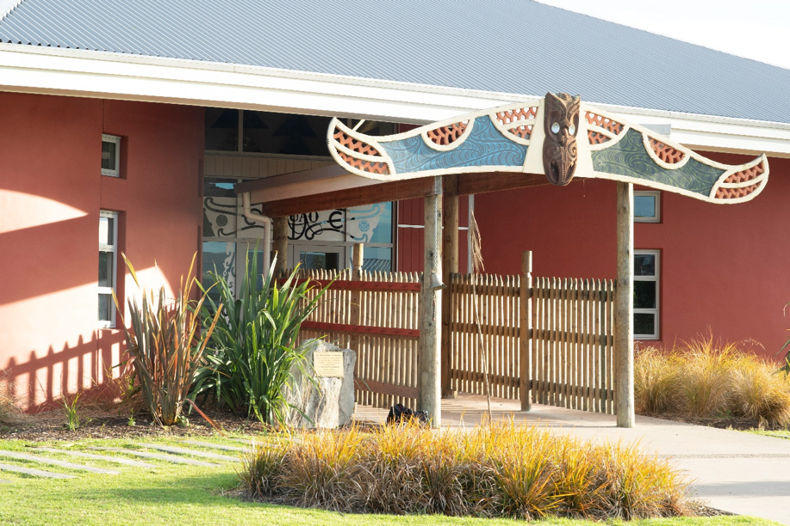

Te Ngohe 1 o te Aromatawai Whakawhanake:
E āhua pēnei ana to āhua i a koe e mahi tonu ana:
- Tīmata ki te mahi/ko te mahi ko te ako tonu rānei (i ngā tau 16 - 25)
- Mahi (i ngā tau 26 – 45)
- Kua tata te whakatā/whakatā (i ngā tau 46 - 65)
Ka pakeke haere koe i a koe e mahi tonu ana, ka rerekē haere ano ngā āhuatangā e pā ana ki a koe. Pēnei i te:
- whakawhanaungā ki tētahi atu, ka noho mā kōrua tahi e utu ngā nama/pire
- whiwhi tohu pōkai rua, tohu paetahi rānei
- whakawhānau tamariki, whāngai rānei
- piki haere o te utu i te nui haere o ngā whēako kua whiwhi i roto i to mahi
- hoko rawa pēnei i te whare, i te motukā rānei
- te hangā whare i rungā papakāingā, whenua whānau rānei
Ahakoa pēhea te rerekē haere o tōu ao, ka pērā anō te āhua o tō hiahia ki te takoha pūtea ki te mahere whakatā.
Ko ngā mahere whakatā penapena pai rawa atu ko ērā e aro ana ki ngā rerekētangā o tōu ao.
I roto i te Mahere Tatauranga Whakatā 1, tatauria ngā wāhi kei te ngāro. Kātahi ka whakautu i ngā pātai e whai ake nei:

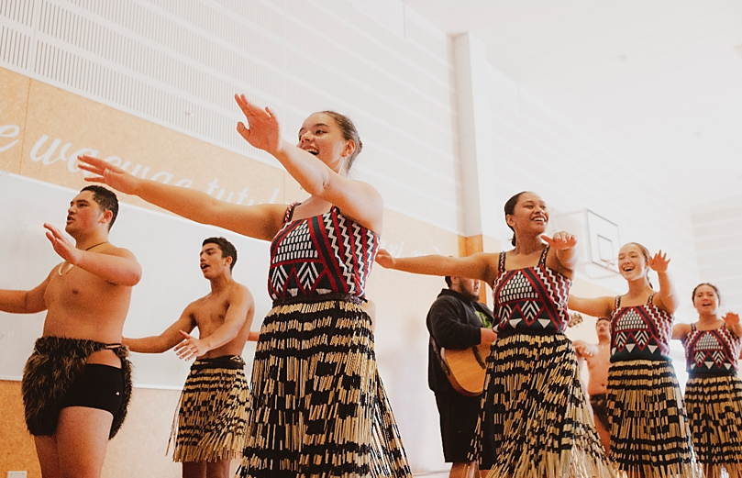

Mahere Tatauranga Whakatā 1
Tau | Te nui ia wiki | Tapeke 52 wiki (ia wiki, ia tau) | Whakatakotoranga Whārite
16 ki te 26 tau | $50.00 | 26 -16 = 10 (ngā tau mai i te 16 ki te 26 tau)  10 (tau) x 52 (ngā wiki ia tau)  = 520  520 x $50 (te takoha ia wiki)  = $__________ | 26 -16 = 10 x 52 =  520 x 50  = $__________ = A
26 ki te 46 tau | $150.00 | 46 - 26 = 20 (ngā tau mai i te 26 ki te 46 tau)  20 (tau) x 52 (ngā wiki ia tau)  = 1040  1040 x $150 (te takoha ia wiki)  = $___________ | 46 - 26 = 20 x 52 =  1040 x $150  = $___________ = B
46 ki te 65 tau | $250.00 | 65 - 46 = 19 (ngā tau mai i te 46 ki te 65 tau)  19 (tau) x 52 (ngā wiki ia tau)  = 988  988 x $250 (te takoha ia wiki)  = $___________ | 65 - 46 = 19 x 52 =  988 x $250  = $___________ = C
Tatauria te nui o te tapeke penapena whakatā,  ma te whakatakotorangā whārite e whai ake nei,  ka tuhi ai ki te pouaka i te taha nei  A + B + C = Y |  |  | $_____________ = Y

Te Aromatawai Whakawhanake mō te Whakatānga
Te Ngohe 2
Mēnā kei te ora tonu tēnei tangāta kua waru tekau mā rima tau te pakeke, e hia te nui o te moni ka whiwhi ia mai i te pūtea kua oti i a ia te penapena. Whakaotia te Tūtohi 1 i raro iho nei.

Tūtohi 1
85 - 65 = 20 (ngā tau mai i te 65 ki 85)  20 (tau) x 52 = 1040 (te nui o ngā wiki mo te 20 tau)  Whakawehea mā te tapeke penapena whakatā  $ ________________ Y  = $ ________________  To utu whakatā ia wiki, ki te ora tonu koe mō te rua tekau tau i muri i tō whakatāngā. | 85 - 65 = 20 x 52  = 1040 / Y = $  ________________

- Kei te pai rānei, kei te kino rānei tēnei nama ia wiki mō te tangata 85 te pakeke? Whakamāramatia mai he aha i pēnei ai o whakaaro.
____________________________________________________________________________________________________________________________________________________________________________________________________________________________________________________________________________________________________________________________________________________________________________________________________________________________________________________________________________________________________________

- E hia tō utu ia wiki mo to whakatānga?

$ _________________

Te Aromatawai Whakawhanake mō te Whakatānga
Te Ngohe 3
He rangatahi koe, kei te rēanga tika ki te tīmata wawe i tō whakarite mahere whakatānga. Ināhoki, he mea nui te whakaaroaro māu ki o whāingā whakatā.
Nā, kua āhua mōhio nei koe me pēhea te nui o te tahua ka whiwhi koe ia wiki i to whakatānga, i roto i te Tauira Tūtohi Whakakitenga i raro nei, tuhia ētahi mea e ngākaunuitia ana e koe, e mahi moni ai koe. Ki te pouaka taurite, tuhia ētahi huarahi e whakatinanahia ai ō whakaaro. Kāore he whakautu tika, whakautu hē rānei, nōu te ao.

Tauira Tūtohi Whakakitengā
Ngā mea e ngākaunuitia ana e au, e mahi moni ai au, ka penapena mō taku whakatānga | Pouako Taurite  Whakaputa whakaaro e tinana ai tēnei kaupapa
Hei tangāta whakatangitangi puoro rongonui | - Ka mutu te kura ka ekea te NCEA mō te puoro  - Kia hanga i tōku ake hōngere tiriata, hei paetuku i ngā waiata hou, te whakatū tira whaiwhai  Mā te moni ka whiwhi ahau, ka hoko whare, ka penapena moni ki te KiwiSaver

To Tutohi Whakakitengā
Ngā mea e ngākaunuitia ana e au, e mahi moni ai au, ka penapena mō taku whakatānga | Whakaputa whakaaro e tinana ai tēnei kaupapa

