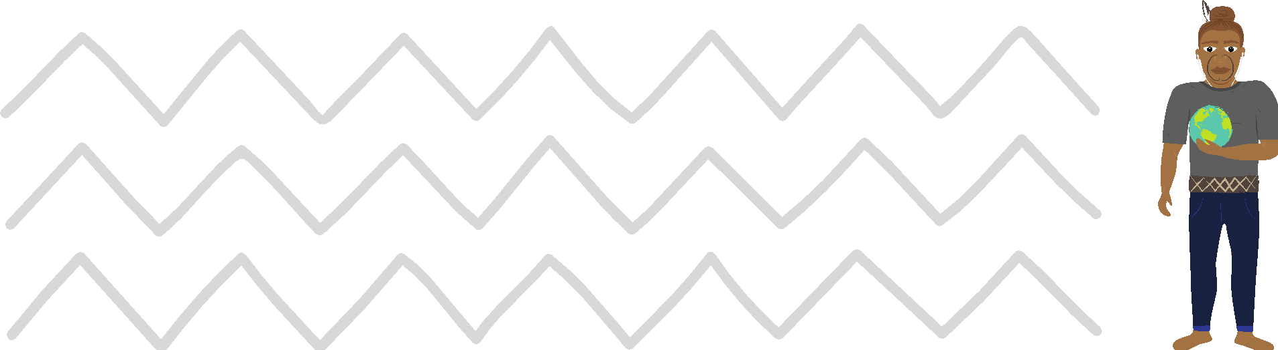
Māui Ātea Te Ngohe Haumitanga 3
Ōku wawata
I tēnei ngohe mā te ākonga:
- e waihanga, e whakaatu hoki tētahi hinonga e whakanui ana i tētahi āhuatanga e kaingākautia ana e ia
- e matapaki, e tautohu hoki ngā āhuatanga o te hinonga ka taea pea hei haumitanga
1. Te waihanga me te whakaatu hoki i tētahi hinonga
e whakanui ana i tētahi āhuatanga e kaingākautia ana
He aha tērā e tino kaingākautia ana e koe?
Ka māmā kē pea te kite i te mea e kaingākautia ana. Mā te whakautu pono
i ēnei pātai ka kitea.
- “He aha pea te kaupapa kōtahi o ngā pukapuka e rima ka pānuihia e au,
ā, kāore au e hinga i te hongehongeā?”
- “He aha tētahi mahi ka taea e au mō te rima tau, ā, kāore he take kia utua ahau mō taua mahi?”
- “Mēnā i a au te pūtea ki te mahi i tētahi mahi, he aha rawa taua mahi?”
Arohia te whakaahuatanga o te mea e kaingākautia ana:
Kia pēnei: E tino kaingākau ana ahau ki te… [whakaahuatia ā-kupu]
E tino kaingākau ana ahau ki te… nā te mea,… [kōrerohia ngā āhuatanga ka whakaihiihi, ka whakawanawana hoki i a koe].
Koinei he tauira: He tino pai ki ahau te tautoko i te hunga e whai ana kia whakaputaina ā rātou tuhinga, kia whakawhanake ake i ō rātou pūkenga tito,
kia whakakētia rānei ā rātou pakihi kia huri hei kaitito.

2. Te Whakamahere ā-Hirikapo i tērā e kaingākautia ana
Whakamahia te tauira e whai ake nei ki te waihanga i tētahi Mahere ā-Hirikapo ka whakawhānui i tērā e kaingākautia ana. Rawekehia te tātauira nei ki tāu i pai ai:
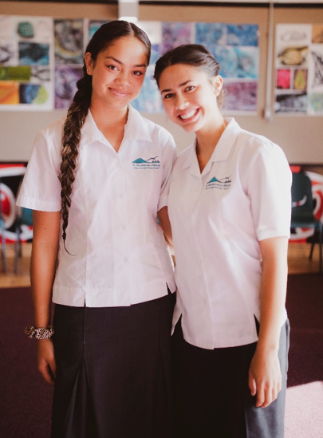
- Aku Tino Runaruna
- Ki rō whare
- Te tākaro kēmu
- Ki waho whare
- Te noho tahi ki te whānau
- Te pānui pukapuka
- Te whakararata ki ōku hoa
- Te waiata
- Te kai rōpere
- Te eke pahikara ki tuawhenua
- I te raumati
- Te tū ki te ua
- Te tīraha ki tātahi
- Tuhia tērā e kaingākautia ana e koe ki waenga pū.
- Whakawhanakehia tō upoko kia 4 neke atu rānei ngā upoko-iti. Kia pēnei pea:
Ki waho whare, Ki rō whare, I te raumati, I te hōtoke, me te aha atu anō.
- Me rangiwhāwhā ake te toro kia whanakehia ngā upoko-iti kia pēnei pea:
Ki rō whare - te mātakitaki i te hongere Discovery.
- E pai ana kia whakawhānui ake i ō whakaaro i a koe ka koke tonu.
Tēnā whakamahia a Google ki te rapu i ētahi atu tauira o te Māherehere ā-Hirikapo

3. Te Māherehere Hinonga Kaingākau
Nā, kua oti i a koe te āhuatanga e kaingākautia ana te tautohu nā reira me huri ināianei ki te whakatakoto i tētahi māherehere hinonga ki te taunaki i ō whakaaro mā te whai i tētahi tukanga māmā, e rima ōna hipanga.
- Whakakitea tō hiranga, ā, ka whakaūngia ai tō whai
He aha i hira nui ai tēnei aronga ki a koe? He aha ngā āhuatanga nui whakaharahara i mutu a i a koe tō mātakitaki i te rangatū pouaka whakaata hou rawa, tō whai rānei i ngā pae pāpaho i tēnei wā?
Mehemea ka taea e koe ngā āhuatanga hira nui o tēnei hinonga te tautohu, ka pai tana noho hei kaiārahi mōu i ngā wā o te pōuri, o te pōkaikaha anō hoki.
- Kia takatū
Kua eke te wā me takatū koe. Waihangahia tētahi kōnae hou. Ko tāu, i āianei, ā, haere ake nei hoki, ko te ohia manomano i ngā mea katoa e hāngai ana ki tō hinonga:
- He aha ngā rangahau hei mahi māu?
- E pai ana kia wāhia tō rangahau ki ngā wāhanga iti?
- Me whai kaitautoko?
- He aha ngā rauemi kei te pīrangitia kia pai ai tō taki i āu mahi rangahau?
- Me ako pūkenga hou?
- Whakatakotoria tētahi mahere
Me tīmata tō whakarite i tō ohia manomano ki ngā hipanga iti. He mea hanga ngā hinonga katoa ki ngā paraka hanganga: Ko ngā pakimaero ka wāhia ki ngā upoko, ngā upoko ki ngā kāpeka, ngā kāpeka ki ngā taki. Kua eke te wā me kimi koe i ngā paraka hanganga mō tō hinonga ake.
- Kātahi, me huri ki te whakarite wātaka
Nō muri mai i tō mārama ki ngā hipanga e tika ana kia whakatutukihia e koe, me huri ki te whakarite wātaka mō tō hinonga. Kāore he aha ka pahawa i te wawata noa iho, nā reira, ki te hiahia mārika koe ki te mahi i tētahi mahi, me āta whakarite i te wā.
Me noho tapu te wā ka whakaritea mō te hinonga.
- Tuhia atu tētahi mea
Ka pōhēhē te tangata he tino hua ka puta mai i te rangahau me te whakamahere. Engari tonu. Mehemea e pono ana tō hiahia ki te whakatutuki i tō hinonga me mātua whakaharatau koe kia eke āu mahi tuhituhi i te korenga hoki o te kaitaunaki, o te taiao tika, o te ora, o te wā.

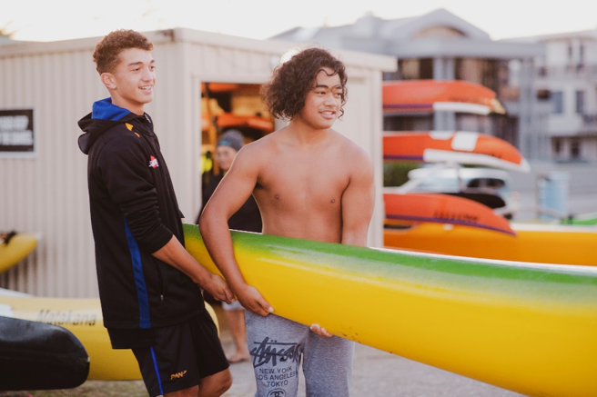

Te ohia manomano
Ohia manomanotia ngā tū ara ka taea te whakawhanake tērā e kaingākautia ana
e koe ki tētahi haumitanga huamoni. He tauira ohia manomano kei te kohinga
Māui Haututū me te kohinga Māui Ātea.

Te whakaaturanga
Tukuna tētahi whakaaturanga poto o te Māherehere Hirikapo o runga ake nei,
te Māherehere Hinonga Kaingākau me te ohia manomano kua waihangahia.
Whakamahia te pūmanawa Powerpoint, te pūmanawa Google Slides rānei hei taunakitanga.
Whakahaerehia tētahi matapakinga ā-rōpū e hāngai ana ki te haumitanga whaitake o tō Māherehere Hinonga Kaingākau mōu, mō tō whānau tae atu
ki tō iwi.

