HEALTH RESOURCE 1
This supporting resource is in three sections and links directly from the Health resource to support student learning. Each part includes the necessary reading and tables required for the learning experience it is linked from.

Table: The four elements of financial wellbeing: class or group learning experience

Enlarge the four elements of financial well-being table onto A3 paper and give each group a copy.

 | PRESENT | FUTURE
SECURITY | Control over day-to-day and month-to-month expenses.  What are the basic necessities that require money?  e.g. rent/petrol/power | Capacity to absorb financial shock.  List all of the events that are considered a financial shock (financial setback) and explain how these might be planned for.  e.g. loss of job/illness
FREEDOM OF CHOICE | Financial freedom to make choices to enjoy life.  What are all of the things that you like to do to enjoy life?  e.g. movies/family celebrations/sports | On track to meet financial goals.  What plans are needed so that choices are available later in life?  e.g. KiwiSaver

- Financial wellbeing influences and impacts
- Influences on wellbeing
- Hauora: The Māori concept of holistic health

Section 1: Financial wellbeing influences and impacts

 | PRESENT | FUTURE
SECURITY | Control over day-to-day, month-to-month finances | Capacity to absorb financial shock
FREEDOM OF CHOICE | Financial freedom to make choices to enjoy life | On track to meet financial goals
Source: US Consumer Financial Protection Bureau, 2015

*

Instructions for students:
Using sticky notes, provide an example for each element in Table 1. Then discuss your examples and justify your choices.

For ideas of daily/monthly expenses look at Smith family budget

Section 2: Influences on financial wellbeing
This can be a class or group learning experience.

Financial wellbeing is when a person/whānau can fully meet their present and ongoing financial commitments. Discuss this statement and describe what this means for you and your family/whānau.

Enlarge the Influences on financial wellbeing table onto A3 paper. Print this table off and give each group a copy.

Instructions for students:

- Add more examples to the social and economic environment column (use some of the work you completed in the first section of this resource). Fill in the attitudes and behaviour column. How would you think and act if you were in this situation? Why?
- Identify potential opportunities or lack of opportunities. Consider what options might/or might not be available to you based on your financial wellbeing
- Rank ways that your solutions make a difference to your personal wellbeing.

Table: Influences on financial well-being

Influences on financial well-being |  | Social and economic environment  What factors affect your family and community? |  | Attitudes and behaviour  (Your response to the social and economic factors).  How might you think and act, and why? |  | Identify potential opportunities or lack of opportunities  Consider what options might/ or might not be available to you based on your financial wellbeing. |  | Personal well being  Rank how satisfied you would feel with your financial situation based on the opportunities  you have identified. Use a 1 to 5 ranking system, with 1 being not satisfied at all and 5 being extremely satisfied.
Security |  | Secure, in control of day-to-day, |  |  |  | What would you do if your
Present  Ability to control day-to-day, |  | month-to- month finances. |  |  |  | day-to-day, month-to-month  finances are all sorted?
month-to-month finances.
 |  | Not financially secure, stress |  |  |  | Give examples of things you
 |  | over day-to-day costs and |  |  |  | might miss out on if you can’t
 |  | finances. |  |  |  | cover your day-to-day costs.
Future  Capacity to absorb future shocks by creating an emergency fund or contingency plan  Freedom of choice  Ability to make choices and to enjoy life knowing that you have a financial plan in place. You don’t want to go into debt to get the things you want. | Capacity to absorb financial shock, for example, job loss, sickness, disability, or divorce. |  |  |  | What do you think an emergency fund might look like?
 | No or limited capacity to absorb financial shock. |  |  |  | If you don’t have an emergency fund in place, how else could you prepare for a financial shock?
 | Financially free to make choices to enjoy life |  |  |  | What is something you would love to do if you had the money to pay for it?
 | Not financially free to make choices |  |  |  | What could you do to reduce debt?
 | On track to meet financial goals |  |  |  | How can you get your money working for you?
 | Not on track to meet financial goals |  |  |  | Who can you get advice from in your community?

Adapted from: Financial well-being: What it means and how to help

Section 3: Hauora: the Māori concept of holistic health

Hauora: the Māori concept of holistic health
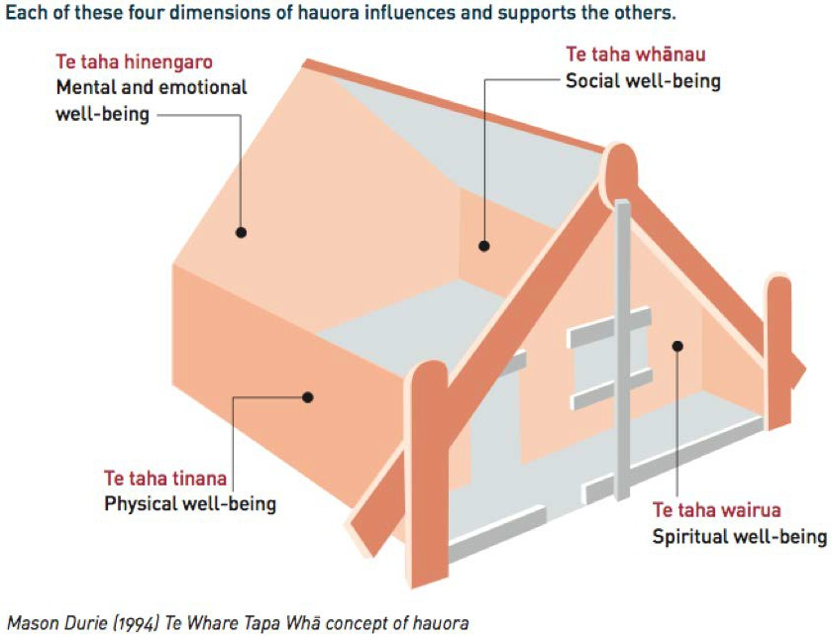

The four dimensions of Te Whare Tapa Whā:
- Te taha hinengaro (mental and emotional wellbeing): mind, thoughts, feelings, attitudes
- Te taha whānau (social, family and community wellbeing): family/whānau, friends, belonging

Te taha tinana (physical wellbeing): sleep, eating, exercise

Te taha wairua (spiritual wellbeing/wider sense of purpose): beliefs, culture, values, world view.

The four dimensions are all related; when one wall of the house is damaged or impacted, it may impact on the others.

Financial well-being and financial sustainability

Financial wellbeing is when a person can fully meet their present and ongoing financial commitments. Financial Sustainability is about growing your money for your future or for the future of others.

This can be a class or group learning experience.

Enlarge the diagram of Hauora: the Māori concept of holistic health and print it on A3 paper.
Instructions for students

Discuss each of the dimensions of Te Whare Tapa Whā and describe how they are relevant to your everyday life.

As a group, decide ways that:
- Financial wellbeing fits into this hauora model of wellbeing
- Financial sustainability fits into this hauora model of wellbeing
- Financial stress fits into this hauora model of wellbeing.

Create a definition for financial wellbeing and sustainability that could be added as an additional dimension to the Hauora model.

Table: The impacts of financial stress

Impact of financial stress | Health  Te taha tinana | Relationships at home  Te taha whānau | Productivity at work or school  Te taha hinengaro | Attendance at work or school  Te taha hinengaro
Describe the impact of financial stress on each dimension of health.
Give examples that relate to each dimension. | Too tired due to job supporting family

Table: Impacts on Hauora: Te whare tapa whā

What are the impacts of financial stress on the four dimensions of Te Whare Tapa Whā model? Record your thoughts in the table below.

Impacts on Hauora:
Te taha hinengaro (mental and emotional well-being) | Te taha whānau (social, family, relationships)
Te taha tinana (physical well-being) | Te taha wairua (spirituality, beliefs, sense of purpose)

