He Ngohe Ako 2: Hangaia Tētahi Papa Moemoeā

Māui Auaha

Wāhanga Rua: He Ngohe Ako

Hei mahi: Hangaia tētahi papa moemoeā
Te Tauira Papa Moemoā

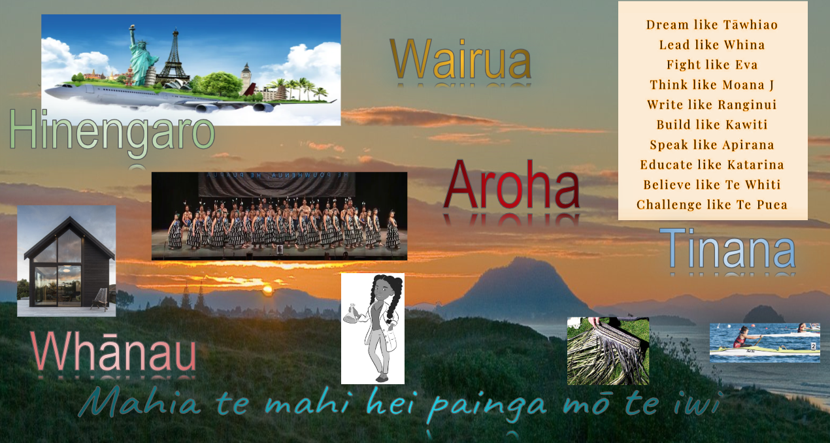
Hei kōkiri i tō waihanga i tō papa moemoeā, tēnā rapua ētahi whakaahua hei whakaatu, hei tohu i ngā wheako, i ngā kare-ā-roto me ngā taonga e hiahiatia ana i tō ao ka mau ki tō papa. Whakamahia ngā whakaahua, ngā pikitia i ngā mōheni rānei, i te paetukutuku rānei. Kei te kapa o ōu ringa te āhua o tō ao Whakamahia ōu whakaawetanga. Whakaarohia te whakaurunga o tētahi whakaahua o tētahi wā i harikoa koe.
Hei āpiti atu, whiriwhirihia he kupu, he kī horipū, he kī hihiko, he whakaaro hoki ka whakakipakipa i a koe. Whakamahia ngā kupu, ngā whakaahua me ngā tohu hei hiki i tō ngākau me tō wairua. He kupu pēnei i te aroha me te whānau, he whakataukī rānei pēnei i te “Mahia te mahi, hei painga mō te iwi”. Ko tā te papa moemoeā he whakaatu i ō whāinga me ngā wawata mō ngā mea katoa.
Tēnā pea ko te whare tapawhā hei tūāpapa mō tō papa moemoeā arā, tērā e whakatairanga ana i te taha wairua, te taha hinengaro, te taha tinana me te taha whānau. He ahakoa tāu me nahanaha, me rangatira te āhua o ngā mea ka whakairihia ki tō papa moemoeā, ā, me pēnā hoki te hanga o tō papa moemoeā kei tīwekaweka, kei rangirua.
Nō reira, kia iti te kupu, kia iti hoki ngā atahanga, ā, kia hāngai ki tō kaupapa, ki ō whāinga mō āpōpō. He kupu hei whakahihiko i te ngākau e tau pai ai ō kare-ā-roto. Inā te nui o ngā whakaahua me ngā kupu ka uaua ki te karu, ā, ka kōtiti ngā whakaaro o te tangata. Kia tau te āhua, kia ngāwari.
He ao toritori tō tātou ao, he ngāwari kia kōtiti i ō whāinga, i ō wawata ahumoni. Nā, kia mutu ana tō papa moemoeā te waihanga, whakairihia ki tētahi wāhi ka ngāwari tō kite i ia rā, i ia rā, kia auau tō moemoeā. Ka pēhea te pātū i tō moemanga?
Kia kaha te hokihoki atu, kia pono, kia titia hoki ō whāinga ki te ngākau ka moe ana koe i te pō, ka oho ana koe i te ata. He kaiwhakaohooho tino pai te papa moemoeā!
He ngohe hei whakawhānui ake:
- Tuaritia tō papa moemoeā ki tētahi atu o tō akomanga. Kia pēnā i tā Te Puea whakataukī, he pai ake kia moemoeā tahi te tangata kia whai hua te katoa.
- Tirohia tō papa moemoeā, ā, ka whakatauhia he aha rā ō matea me ō hiahia?

