Nau mai haere mai!

Welcome to the Expert Investing module.
Name:
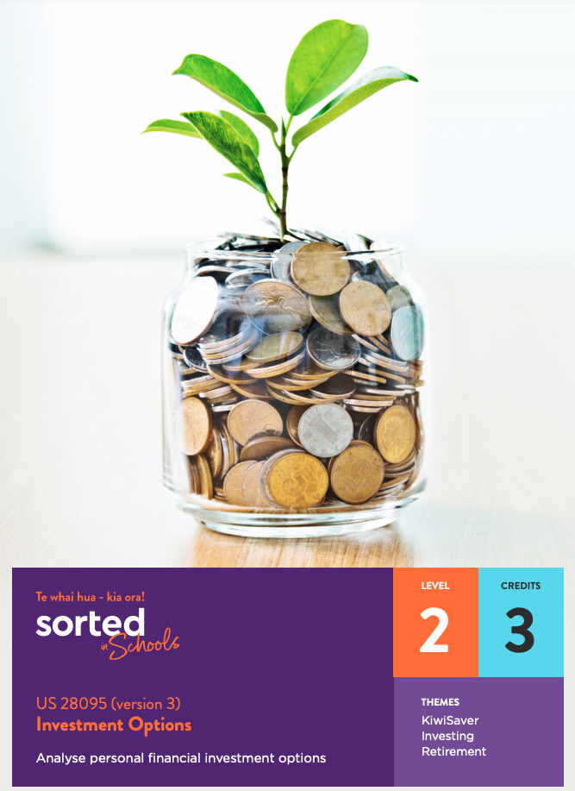
This module supports you to develop your ability to analyse personal financial investment options and to understand which investment options are a good match for different investor types.
US 28095 Analyse personal financial investment options (version 3)
Level 2
Credits: 3
You will be assessed on how well you:
- analyse two investment options in terms of:
○ costs
○ timeframe
○ deposit and/or contribution options
○ risks
○ returns.
- make links to the suitability of your choices for the individual investor profile.
- justify the suitability of your selected investment options for the individual investor profile.

Evidence/Judgements for Achievement | Evidence/Judgements for Achievement with Merit | Evidence/Judgements for Achievement with Excellence
You need to:  - analyse two investment options (KiwiSaver and one other) in terms of their:  - cost  - timeframes  - deposit and/or contribution options  - risks  - returns.  The two investment options need to be relevant and realistic for the investor’s profile. | As well as meeting the requirements for Achievement, you need to:  - explain why the two investment options are a good match for the investor’s profile. | As well as meeting the requirements for Merit, you need to:  - justify the suitability of the two investment options.  The justification needs to be relevant and reasonable.

Potential links to NCEA Level 2 Achievement Standards
You may be able to use your knowledge, content, and modified work in this module and assessment task as evidence towards the following Achievement Standard:
- AS 90846 Conduct market research for a new or existing product
- AS 91101 Produce a selection of crafted and controlled writing
- AS 91102 Construct and deliver a crafted and controlled oral text
- AS 91103 Create a crafted and controlled visual and verbal text.
Discuss with your teacher whether this is an option.

The focus of this module is on how to tailor investments to suit an individual’s circumstances, expectations and personality. Working through this module will help you to understand which investment options are a good fit for you, your friends and your whānau, both now and in the future.
In this module you will explore:
- Topic One: Investor profiles —factors that shape an investor profile; five types of investors
- Topic Two: Investing in KiwiSaver – timeframe; how much you need to invest; risks; returns; ethical considerations
- Topic Three: Investing in shares – timeframe; how much you need to invest; risks; returns
- Topic Four: Investing in term deposits– timeframe; how much you need to invest; risks; returns
- Topic Five: Investing in bonds – timeframe; how much you need to invest; risks; returns
- Topic Six: Investing in managed funds – timeframe; how much you need to invest; risks; returns
- Topic Seven: Investing in property – timeframe; how much you need to invest; risks; returns
- Topic Eight: Choosing a suitable investment – matching investments to investor profiles.

Resources
There are lots of useful resources for exploring investment options.
Sorted in Schools resources that have particular relevance to this module are:
- Investing Sorted booklet
- Investing PowerPoint
- Investment infographic
- KiwiSaver Sorted booklet.
You can find these resources on the Student Activities page of the Sorted in Schools website by clicking on Theme and selecting either Investing or KiwiSaver from the dropdown menu.
Be sure to watch the fun, informative video that accompanies this module - Investment Options video

Other useful tools and websites include:
- Sorted.org guide to saving and investing
- Sorted.org investor kickstarter tool
- Sorted.org Smart Investor tool.
Let’s begin to explore investment options that can help you to achieve your financial goals!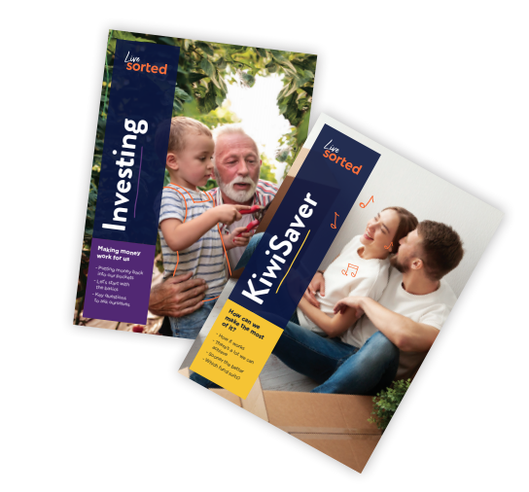

Topic One: Investor profiles

Learning outcomes for Topic One:
- Understand factors that define a person’s investor profile
- Understand common types of investors.
Success criteria
You should complete all activities in this topic. They will help you to meet the assessment requirement of identifying investment options that suit an individual investor profile.
‘Ko wai au?’ is a question commonly asked in te ao Māori. Answering the question ‘who am I?’ requires more than simply sharing your name. It’s about who you are, where you are from, what is important to you, and what has shaped you. Our sense of identity is shaped by all sorts of things: our whakapapa, our culture, our whānau, our friends and our experiences.
In this module, the focus is on knowing who you are as an investor. An investor is a person or organisation that puts money into things such as financial schemes or property with the expectation that they will make a profit from their investment. When you think of an investor, what image comes to mind? Share your thoughts on this with a classmate.
For some people, the concept of an investor is associated with someone in a suit, often a male, and is not something that they feel they can be or do. However, anyone can be an investor. In fact, if you have a bank account, you are already an investor, because you’re earning interest on your money.
There are lots of different ways to invest. For example, nearly 3 million people in Aotearoa New Zealand have joined KiwiSaver – all of these people are investors. If you know someone who owns the home they live in, they have invested in property; if you know someone who is studying, they are investing in their future by gaining qualifications. You may have whānau members who have invested in an iwi-based investment scheme.
Watch this 6 minute Financial Markets Authority (FMA) video to get an overview of what investing involves.
Investing can help us to achieve all sorts of goals; from paying for our education, supporting a whānau member, buying a home to having money to spend in retirement. Before you choose to invest, it’s important to know:
- what type of investor you are
- what a typical mix of investments for your investor type is
- the risks come with those investments
- what sorts of returns you can expect from your investments.
This focus of this first topic is on investor profiles. A profile is a short description of who someone is and an investor profile is a description of what type of investor someone is.
Just like your identity, your investor profile is made up of a range of factors including:
- Your age: age is important because financial needs and goals change as we grow older. For example, as a teenager, you might want to invest in study. When you are in your twenties, you might start thinking about how to buy a house. You can start to prepare for retirement at any age – the earlier the better!
- Income: Income is the money you have coming in on a regular basis from earned or unearned income.
- Timeframe: how soon will you need the money? The purpose of an investment is to meet a financial goal, so you need to be clear about when you will want to access the money you have invested, along with any returns. For example, some investments such as KiwiSaver can only be accessed to buy your first home or when you reach the retirement age of 65, so investing in KiwiSaver won’t help you meet a goal of paying for an education.
The length of an investment also relates to how much risk you are willing to take. Some investments go up and down in value more than others. If you’re investing for a long time, say thirty years, it won’t matter if there are some ups and downs along the way. However, if you want to use your investment in five years, it might be better to choose a low-risk investment that offers a predictable return so that you can make sure that the money is there when you need it for your goal.
- The returns you hope to make: A return is how much you get back from investing, in other words, how much your investment grows over time (or not!). Returns can be both positive or negative; if you make money, you have a positive return, if you lose it, it’s a negative return. Obviously, no one wants a negative return, but some people are prepared to take greater risks with the hope that an investment will bring a greater return, while other prefer a safer, more predictable option.
- Your family situation, for example, what type of family support do you have and what family obligations do you need to meet? If a person is struggling to meet the everyday needs of themselves or their whānau, then investing money might not be a good option until they are in a stronger place financially.
- Your financial stability, for example:
  - Do you have savings?
  - Do you have insurance if something goes wrong?
  - How much debt do you have?
  - How secure are your existing sources of income? For example, do you have a permanent job?
These questions are important because sometimes when you invest money, you can’t access it for months or even years. It’s important to be able to cope financially with the ordinary ups and downs of life before you start investing.
- Your goals, for example, how much money you want to get from your investments. Remember that risk and return are related, so seeking a big return from an investment usually involves accepting quite a lot of risk.
- Outlook: Your outlook is your point of view or attitude towards life. In terms of investing, your outlook is how you feel about making financial decisions. Are you confident with taking risk? Would you prefer a safe, reliable option even if the returns are lower? Emotions are important when it comes to money decisions, and investments should help to reduce stress, not create it!
- Values: For some people, choosing an ethical investment is really important, even if it means they make less money from their investments over time. For example, some people don’t want their money invested in fossil fuels, weapons or tobacco because these things don’t align with their values. If you care about climate change, global stability or people’s health, it’s probably important to you to know how your money is being invested. People have a lot of power when it comes to choosing their investments, and the rise in ethical investment options is being driven largely by investors in their twenties and thirties.
Your cultural values are also part of your investor profile because the purpose of an investment is to meet a goal, and people’s goals are often closely connected to what is valued in their culture.

Types of investors
There are 5 main types of investors.
A defensive investor: A defensive investor is someone who doesn’t want their investment to go down in value at any time. They want a low-risk investment that possibly gives low returns but is predictable and stable. Being a defensive investor is often a good option if you want to use your money within the next three years.
A conservative investor: A conservative investor is someone who is willing to take some ups and downs in their investment but still wants to play it safe. A conservative investor often wants to be able to get regular income from their investments. Being a conservative investor is often a good option if you want to use your money after four or five years.
A balanced investor: As the name suggests, a balanced investor is someone who is right in the middle of the investor types. A balanced investor is comfortable with seeing the value of their investments fall a little and they’re aiming for a mid-range long-term return. Being a balanced investor is often a good option if you want to use your money after six to eight years.
A growth investor: A growth investor is someone with a long term view who wants fairly high growth and is in a position to wait for it. A growth investor can handle seeing their investment balance fall quite a lot. Being a growth investor is often a good option if you want to use your money after nine to twelve years.
An aggressive investor: An aggressive investor is someone who is prepared to take some massive downs with the expectation that, over a long period of time, they will make some massive wins. Being an aggressive investor is often a good option if you are in a strong financial position and want to use your money after 13 years.

Activities
- Download and read the Investing Sorted Booklet from the student activities page of the Sorted in Schools website. This booklet provides useful background knowledge about investing that will help you throughout the module and in your assessment.
Using the booklet or another source to help you, write an explanation of the following terms in your own words:
- risks
- returns
- inflation
- volatility.
- Watch the Future Focus video.
- a. Invent two characters, or use two from the Future Focus video, and use the table below to create an investor profile for each character. Try to make them quite different from each other. The options provided in the table are based on an investor quiz you will be doing for each character. You’ll be using these characters throughout the module.
Assessment tip:
In your assessment, the investment timeframe you’ll be working with will be longer than three years.

Character’s name:
Age:
Income: amount earned per year. This income can be earned or unearned.  [circle one option] | Less than $40,000  $40000 to $80000  $80000 or more
Timeframe: How soon will they need the money?  [circle one option] | 4-9 years  10 or more years
Savings: How much money does this person have in the bank? A recommended amount for an emergency fund is 3-months’ income  [circle one option] | None  Some savings and insurance  Enough savings to live off for several months
Returns: a return is the amount of money that you get back from an investment. For example, if you invest $1000 and get back $1200, the return is $200.  [circle one option] | Happy to get back as much money as they put in  Wants the money to grow over time  Ready to take some big risks to get a good return
Debt: how much money a person owes. When it comes to investment profiles, debt doesn’t include student loans because you don’t have to pay interest on them but does include money owed as a mortgage (money borrowed to purchase a home).  [circle one option] | More than one year’s income  Debt worth less than a year’s income  No significant debt
Outlook: how comfortable does the person feel about the value of their investment going up and down over time?  [circle one option] | Nervous about taking risks with money  Okay with making some risks, but nothing too significant  Comfortable taking risks
Security of job, business or finances:  How likely it is that this person’s situation will stay as it is for at least 5 years?  [circle one option] | Not likely  Reasonable  Very likely
Comfort with taking risks: all investments involve some risk. The higher the risk, the higher the returns you might get – but the chances of losing money are also higher. How much risk is your character prepared to take?  [circle one option] | Low  Medium  High

b. Use the Sorted.org Investor kickstarter to identify what type of investor each of your characters is.
Assessment tip:
This tool will be useful when you do your assessment, so it’s good to become familiar with how it works.

- Take a screenshot of the pie graph showing the mix of investments that suit each character’s investor type. If the two graphs look very similar, you may want to change some aspects of one character.
- Read the guide to investor types on the Sorted.org website. Look these terms up and try to define them in your own words, using examples to support your definitions.
- duration
- risk
- returns
- liquidity.
Before moving on to Topic Two, check that you understand:
- what an investor profile is
- key factors that shape a person’s investor profile
- what risk and returns are
- the five main types of investors.

Topic Two: Investing in KiwiSaver

Learning outcome for Topic Two:
- Understand the timeframe, investment options, risks, returns, and costs involved in KiwiSaver.
Success criteria
You should complete all activities in this topic. They will help you to meet the assessment requirement of identifying the cost, timeframes, deposit and/or contribution options, risks, and returns of KiwiSaver investments.
Over the next few topics, you’ll be exploring different types of investments. The first investment option is KiwiSaver.
Assessment tip:
In your assessment task, you need to analyse two investment options. One of these investment options must be KiwiSaver, which is a kind of managed fund. The other investment options you choose can include:
- shares
- term deposits
- bonds
- property.
You can also choose another form of managed fund as an investment option.
When you analyse the suitability of an investment option, you need to discuss each of the following factors:
- the timeframe that the investment is for and when you can access the funds
- how much you need to invest
- the risks of the investment
- the expected or potential returns of the investment
- the cost of the investment, for example, any fees or taxes you have to pay.
To help you prepare for your assessment task, the notes and exercises for each investment option have been structured around these five factors.

What is KiwiSaver?
KiwiSaver is a voluntary investment scheme set up by the government to help people get ready for retirement.
People who choose to join KiwiSaver typically put money into a KiwiSaver account each time they get paid. The payments happen automatically, so it’s a really easy way to put money aside. Investment experts invest the money that is in KiwiSaver accounts so that it grows over time.
Timeframe
KiwiSaver funds are mainly for retirement, so even though it’s your money, you can’t use it until you turn 65.
An important exception is that you can use your funds to help buy your first home. You can do this if you have been a KiwiSaver investor for at least three years.
In extreme financial situations, you can also request access to your funds before you turn 65. However, this is usually only if there is no other way for you to access money. For example, if you owned a house, you would need to sell the house and use that money before you could access your KiwiSaver funds, so it’s not helpful to rely on these KiwiSaver funds as a backup plan.
In 2019, Tim Fairhall, an Auckland man with Down syndrome, helped to create a law change that makes it possible for people born with life-shortening conditions to be able to access their KiwiSaver funds earlier than 65. You can read about Tim and the change of law in this article.
How much do you need to invest?
If you are employed by someone else, you can choose how much of your pay goes into your KiwiSaver account. The options are 3%, 4%, 8%, or 10% of your pay. You can also make additional voluntary payments.
If you are self-employed, a contractor, on a benefit, or not currently working, you can make contributions directly.
Once you join KiwiSaver, you generally keep contributing unless you:
- stop working
- move overseas permanently
- are seriously ill
- are in significant financial hardship.
However, if you need to, you can take a break from saving for 3–12 months and you can do this more than once.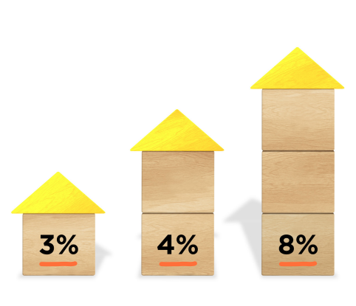
Risks of investing in KiwiSaver
When you join KiwiSaver, you can choose the level of risk you want to take. There are five levels and each one corresponds to a different investor profile. For example, if you want a low level of risk, you might choose a defensive fund. If you want a higher level of risk, with potentially higher returns, you might prefer a growth or aggressive fund. You can change your fund type at any time – it’s an easy process that you can do online. You can read more about KiwiSaver fund types and levels of risk on the Sorted website.
If you don’t choose a fund when you join up, you will be put in a default fund. In 2020, the government changed the default fund from a Conservative fund to a Balanced fund. This graph shows the number of New Zealanders who have invested in KiwiSaver. As you can see, the number of people choosing to invest their money in the scheme has been growing steadily. The number of people who end up in a default fund has stayed largely the same.
Returns from investing in KiwiSaver
People who invest in KiwiSaver are often surprised at how quickly their money mounts up. This is because as well as your own contributions, your employer also contributes at least 3% of your pay. That’s extra money that you don’t get if you’re not a KiwiSaver investor. The government also puts money in, up to $521 a year. On top of this, your money usually grows as a result of being invested.
The expected return will depend on which fund you choose to put your money into. For example, if you choose a Growth fund, you are likely to make more money over a 20 year period than if you choose a Conservative fund. This KiwiSaver Savings calculator gives you an idea of how much you can save before you retire and how much money these savings might give you per week when you retire.
Costs related to KiwiSaver investments
When you invest in KiwiSaver, you pay a fee to your fund manager to pay for the investment, management and administration costs of running the scheme.
This KiwiSaver fees calculator lets you see what fees you are likely to be charged over the life of your investment. Some funds charge higher fees – these are often funds that are more actively managed, which means they might provide a higher return.
You also pay tax on your investments, which is taken off automatically by your fund manager.
Ethical options related to KiwiSaver
For some KiwiSaver investors, it’s important that the ways their money is being invested aligns with their values. For example, some KiwiSaver fund managers invest money in companies that make money out of selling land mines, weapons, tobacco or fossil fuels. “Socially responsible” KiwiSaver providers offer options that can filter out investments like these.
You can read more about ethical KiwiSaver investments on the Sorted.org website.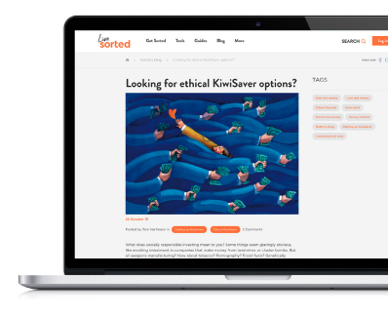

Activities
- Download and read the KiwiSaver Sorted Booklet to make sure you have a good understanding of the KiwiSaver scheme.
- Use the KiwiSaver Pick a Path interactive to explore ways that people’s choices impact on their KiwiSaver funds at retirement.
- Use the KiwiSaver fees calculator to test out some different contribution and fund levels for the two characters you created in Topic One. Use the tool to find out how much money they might have in their KiwiSaver funds at retirement.
- Use the KiwiSaver fees calculator to work out how much the two characters would pay in fees if they invest in KiwiSaver.
- In 2020, the government changed the default fund for KiwiSaver investors who don’t select a fund themselves to a Balanced fund. Prior to this, the default fund was a Conservative fund. Discuss with a classmate why you think the government made this change.
Before moving on to Topic Two, check that you understand the following aspects of investing in KiwiSaver:
- the timeframe
- how much you need to invest
- risks
- returns
- ethical considerations.

Topic Three: Investing in shares

Learning outcome for Topic Three:
- Understand the timeframe, investment options, risks, returns, and costs involved in investing in shares.
Success criteria
You should complete all activities in this topic. They will help you to meet the assessment requirement of identifying the cost, timeframes, deposit and/or contribution options, risks, and returns of investments that suit an investor profile.
The next investment option you will explore is shares.

What are shares?
When you buy a share, you’re buying a small part of a company and a share in any profit that the company makes. You can buy shares directly or you can buy them as part of a managed fund. For example, if you invest in KiwiSaver some of your money may be invested in shares chosen by your KiwiSaver provider, depending on the fund you choose.

How to buy shares
Shares can be listed on the stock exchange which is an electronic marketplace where people buy and sell shares. The Aotearoa New Zealand stock exchange is called the NZX.
To buy and sell shares on the share market, you need to place an order through a broker, which is a company that has a license to buy and sell shares on behalf of other people.

Timeframe
Shares can go up and down in value, so investing in shares can be a bit of a roller coaster ride. This investment option works best for someone who is investing for a long period of time – 10 years or more.
You can choose to sell your shares at any time, but it’s good to sell them at a time when their value has gone up so that you can make a profit on them.
If share prices fall, your investment loses some of its value, but you won’t lose money unless you sell your shares. You don’t want to be forced to sell your shares when prices are low just because you need your money quickly.

How much money do you need to invest?
When you buy shares, there’s no minimum level of purchase. In fact, there are companies that let you buy a fraction of a share if you can’t afford to buy a whole one.

Risks of investing in shares
Shares can grow your investments over time, but they also come with risk. Shares prices go up and down – this is called volatility. An investment with a high level of volatility can go up or down very quickly.
Factors that make a share price go up and down include how well the company is doing financially as well as economic factors that affect the whole stock market.
Some key risks related to shares are:
- Company and industry risk: The performance of a company or an entire industry affects the value of their shares. For example, if a company or industry starts to lose money or profitability, the value of its shares is likely to go down.
- Market risk: Sometimes events happen that affect the global financial market, making the price and value of all shares go down. Examples include recessions, changes in interest rates, natural disasters, or a pandemic.
One way to manage risk when you invest in shares is to diversify, which involves spreading your risk by choosing a range of different companies or industries to invest in. For example, instead of buying one share for $800 you can spread the investment risk by buying 80 shares worth $10 each in different companies, industries and countries around the world.

Returns from investing in shares
There are two ways to make money from shares:
- You can earn income from shares, which are a share of the profit that the company makes. This is called a dividend. Some companies pay regular dividends, for example, once a year. Other companies pay dividends more randomly and some companies don’t pay any dividends.
- You can make money through capital gains. A capital gain is when you sell something for more than you paid for it. You might choose to sell the shares you own to make money from them that way.
You can also lose money by buying shares. For example, if the selling price of a share goes down, but you want to sell the shares that you own, you will lose money. This is called a capital loss.

Cost related to investing in shares
When you buy shares, you have to buy them through a stockbroker. A stockbroker will charge you a fee and will also take a small percentage of any profit you make. This is called a commission. You may also pay a monthly fee.
As with other forms of income you need to pay tax on any profits you make from shares.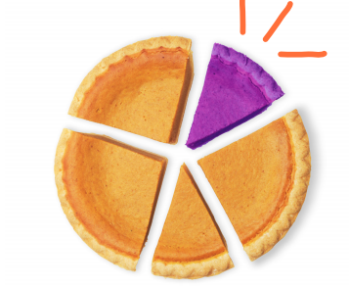

Activities
- Read the Sorted guide to investing in shares.
- Return to the Investor Kickstarter page and select the Defensive Investor Type from the dropdown menu. Scroll down to see the mix of investments. Which investment option makes up the biggest proportion of the pie graph?
Move through the different investor types from Conservative to Balanced to Growth to Aggressive. For each investor type, observe how the proportions of each investment option changes.
- What major changes do you notice as you move through the investor types?
- i. What are the advantages and disadvantages of being an Aggressive investor?
ii. What are the advantages and disadvantages of being a Balanced investor?
Before moving on to Topic Three, check that you understand the following aspects of investing in shares:
- the timeframe
- how much you need to invest
- risks
- returns
- costs.

Topic Four: Investing in term deposits

Learning outcome for Topic Four:
- Understand the timeframe, investment options, risks, returns, and costs involved in investing in term deposits
Success criteria
You should complete all activities in this topic. They will help you to meet the assessment requirement of identifying the cost, timeframes, deposit and/or contribution options, risks, and returns of investments that suit an investor profile.
The next investment option explored in this module is term deposits.

What are term deposits?
A term deposit is a special kind of savings account. When you set up a term deposit with a bank, you agree not to withdraw any of your money for a fixed period of time, say 30 days or 5 years. If you take your money out before the agreed amount of time, you’ll be charged a penalty such as earning a lower rate of interest. On the upside, a penalty can be a good incentive not to splash out and to only use these funds if you really need them. Term deposits usually offer a higher interest rate than most savings accounts. Term deposits won’t make your money grow very fast but they are low risk.
Timeframe
A term deposit can vary from 30 days to five years. When you set up a term deposit, you agree not to touch the money for this amount of time.

How much do you need to invest?
Most banks require a minimum deposit, for example $5000. You can’t add to this amount over the term (time period) of the investment. The rate of interest you get is often higher if you invest a larger amount or if you are investing for a longer-term.

Risks of investing in term deposits
Term deposits are a steady and reliable way to grow your savings. They are a very low-risk form of investment.
One risk with a term deposit is that unexpected circumstances may mean that you have to break the agreement. This can involve a penalty or you may lose some of the interest you would have earned if you had left the money in the account for the full term.
In terms of achieving a financial goal through investing in term deposits, because the returns tend to be low and are taxed, the value of your funds may not keep up with inflation.

Returns from investing in term deposits
Term deposits don’t make a lot of money, but you can earn more interest on them than you would if you left your money in a normal savings account.
Term deposit interest rates go up and down, but once you have set up a term deposit, the interest rate on that investment won’t change, so you can work out exactly how much you will earn from your investment (or you can ask your bank to work it out for you).
This payment is often paid at the end of your term. For terms longer than a year, you might be able to arrange to have your interest paid into your bank account more regularly, for example, every month or every six months. This way a term deposit can provide regular income.

Costs related to investing in a term deposit
It usually doesn’t cost anything to set up a term deposit, but you will pay tax on any interest you earn.

Activities
- Read Bank deposits – Investing in bank deposits and savings. Based on what you have read, what are three important pieces of information you would give to a friend or whānau member if they asked for advice about investing in a term deposit?
- Compare the term deposit rates offered by two different banks. Find out which bank has the best interest rate for someone wanting to invest:
- $5000 for one year
- $10,000 for 3 years.
- Find a bank that provides an interest calculator for term deposits. Use the calculator to work out:
- how much interest you can earn on a $5000 deposit with a 2-year term.
- how much tax you will pay on your earnings.
Before moving on to Topic Four, check that you understand the following aspects of investing in term deposits:
- the timeframe
- how much you need to invest
- risks
- returns
- costs.

Topic Five: Investing in bonds

Learning outcome for Topic Five:
- Understand the timeframe, investment options, risks, returns, and costs involved in investing in bonds.
Success criteria
You should complete all activities in this topic. They will help you to meet the assessment requirement of identifying the cost, timeframes, deposit and/or contribution options, risks, and returns of investments that suit an investor profile.
Bonds are another way to earn interest.

What are bonds?
When you buy bonds, you are lending your money to a government, council or company that promises to pay you back in full on a specific date. For example, if a city wants to build a bridge, they can issue bonds to raise money for it. You earn interest at a fixed or agreed rate.

How to buy bonds
You can buy bonds through a broker or online. Many banks provide access to brokers who can buy bonds for you.

Timeframe
The term of a bond is set by the person who issues them and can be anything from 1 to 30 years.
One advantage of bonds is that you can sell them when you want to. In this way they are different to a term deposit because you don’t have to wait for a certain amount of time to get your money back, along with any returns. However, the price of bonds can go up and down.

How much money do you need to invest?
You can start investing in bonds with as little as $1.00. Some bonds have restrictions on them, for example, only people who are New Zealand residents can buy Kiwi Bonds.

Risks of investing in bonds
Bonds are considered to be safer than shares, but still have some risk. If you invest in bonds, you will get back what you put in, plus the interest rate you were promised. However, if you need to sell the bonds early you might not get this rate.
If interest rates for other options such as term deposits go up over time, you may find that your investment in bonds is earning you less than you could earn from a term deposit. If there is a high rate of inflation, then the interest you earn from your bonds may be lower in value than you expected.
All bonds have an official rating that tells you how risky they are. Some bonds are safer than others, for example, bonds issued by a government or a council may be safer than bonds offered by a company. If a company you have lent money to goes broke, you could lose your investment. Safer bonds tend to earn lower interest than riskier bonds.

Returns from investing in bonds
Bonds are a low-risk investment so their returns tend to be quite low. However, bonds tend to pay a higher return than term deposits, so they can be a good option if you want a steady, predictable return from your investment.

Costs related to investing in bonds
When you buy bonds, you pay a brokerage fee that is usually a fixed amount per trade. This means that the more you trade, the more expensive investing becomes.
You also pay tax on any profit you make.

Activities
- Read about Kiwi Bonds on this Treasury webpage.
- Who can and can’t buy Kiwi Bonds?
- What is the minimum amount you can invest?
- What are the options in terms of length on investment if you invest in Kiwi Bonds?
- How does the interest you can get from bonds compare with the interest you can get from a bank?
Before moving on to Topic Three, check that you understand the following aspects of investing in bonds:
- the timeframe
- how much you need to invest
- risks
- returns
- costs.

Topic Six: Investing in managed funds

Learning outcome for Topic Six:
- Understand the timeframe, investment options, risks, returns, and costs involved in investing in managed funds.
Success criteria
You should complete all activities in this topic. They will help you to meet the assessment requirement of identifying the cost, timeframes, deposit and/or contribution options, risks, and returns of investments that suit an investor profile.
Not everyone feels confident about investing in bonds, shares or other investments, but you can pay a financial expert or organisation to do this for you. This investment option is called a managed fund.

What is a managed fund?
A managed fund is a fund managed by a team of experts who invest your money in a mix of ways, such as shares, bonds or cash. KiwiSaver investments are a form of managed fund, but there are other options as well.
You can buy managed funds from a fund management company or through a bank.

Timeframe
When you invest in a managed fund, you usually buy an investment unit. You can sell these units whenever you want.

How much money do you need to invest?
You can invest in many managed funds for less than $500. Once you’ve invested, you can add much smaller regular payments. These additional payments help you grow your investment over time.
Some online platforms enable you to invest at a much lower cost, which means that you can start a managed fund with just a few dollars.

Risks of managed funds
Like KiwiSaver, if you invest in a managed fund, you can select a fund to match the level of investment risk you’re comfortable with.
The Investor kickstarter tool that you used in Topic One can show you a typical mix of different investments options for each investor type. The mix of investment options reflects the level of risk different people are prepared to take. For example, shares and property carry more risk than bonds or cash, but can also provide higher returns. A typical investment mix for an “aggressive” investor will have a higher proportion invested in shares and property than the mix used for a “conservative” investor.
Sometimes the value of a fund will drop in value, making it worth less than you paid for it. There is also a risk that the account management fees will significantly reduce your return on your investments.

Returns from investing in managed funds
Long-term managed funds usually have higher returns than term deposits, but can go up and down over time. You can earn income from managed funds as well as getting capital gains when the value of your units in the fund rise.

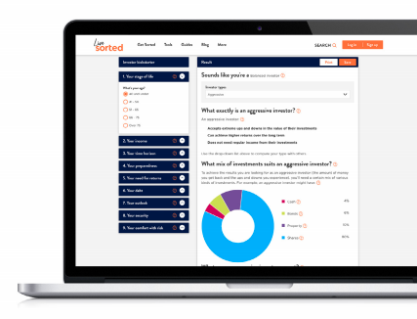

Costs related to investing in managed funds
In a managed fund, you pay a manager to administer it and to choose the investments. Fees can vary greatly between different fund managers and between different types of funds. These costs will impact on how much money you make, especially in the long term.
You pay tax on any profits your managed fund makes.

Ethical options related to managed funds
As with KiwiSaver, you can choose not to invest in products that are socially or environmentally damaging, for example, weapons, cigarettes or products that promote gambling or fossil fuels.

Activities
- Download and read the Sorted guide to managed funds.
- If you are new to investing, what are two benefits of managed funds?
- What is a key difference between KiwiSaver and other managed funds?
- Return to the investor kickstarter tool.
- Compare the suggested combination of investments for the five investor types. What pattern do you see as you move from Defensive through to Aggressive investors?
- Scroll down to view a graph showing the difference that regular contributions can make to a managed fund.
Before moving on to Topic Seven, check that you understand the following aspects of investing in managed funds:
- the timeframe
- how much you need to invest
- risks
- returns
- costs.

Topic Seven: Investing in property

Learning outcomes for Topic Seven:
- Understand the timeframe, investment options, risks, returns, and costs involved in investing in property.
Success criteria
You should complete all activities in this topic. They will help you to meet the assessment requirement of identifying the cost, timeframes, deposit and/or contribution options, risks, and returns of investments that suit an investor profile.
Buying a home is something many New Zealanders aspire to. It can take years of serious saving to build up a deposit to buy a house, but if you can manage it, owning your own home can help to create a financially secure future for you and your whānau.
The focus of this topic is on investment properties. The difference between an investment property and a home is that you earn income from it.
There are two types of returns from property investment:
- income from rent.
- increases in the value of the property over time. This type of return is called a capital gain.
Investing in property requires much more work than more passive investments such as term deposits, shares and bonds. However, the long term returns from property investment can be significant.

Timeframe
People buy investment properties as a long-term investment. Often the biggest return comes from the value of the property increasing, but this might take years. Pulling out of the investment can take quite a bit of time because you need to be able to sell the property.
In the short term, there might be little or no profit from rent because of the costs involved in owning property.

How much do you need to invest?
Investing in property requires a major financial commitment. You need a significant deposit before you can get a home loan to pay for the property.
Looking after an investment property requires ongoing financial commitments, for example, insurance and maintenance. However, hopefully the income that you get from renting it out can cover most or all of these.

Risks of investing in property
Like all investments, investing in property carries risks:
- If you need to sell the property at a time when it has dropped in value, you might be left with a debt.
- Interest rates on home loans might increase, reducing the amount of money you can make from the property.

Returns from investing in property
One of the benefits of investing in property is that it has two types of potential returns. It can be handy having additional income coming in and the income from rent might cover all the costs of mortgage repayments, insurance and maintenance.
Often the biggest return from investing in property comes from capital gains.

Costs related to investing in property
Investing in property has ongoing costs, for example, mortgage repayments, lawyer’s fees when you purchase the property, insurance, rates and maintenance.

Activities
- Read the Sorted.org guide to investing in property.
- Read this Stuff article about two young property investors.
- What evidence is there in the article that property investments are more work than term deposits or shares?
- Are property investments a long or short-term investment? Explain your answer.
Before moving on to Topic Eight, check that you understand the following aspects of investing in property:
- the timeframe
- how much you need to invest
- risks
- returns
- costs.

Topic Eight: Choosing a suitable investment

Learning outcomes for Topic Eight:
- Know how to choose an investment option that suits an investor’s profile
Success criteria
You should complete all activities in this topic. They will help you to meet the assessment requirements of explaining why two investment options are a good match for a person’s investor profile and justifying the suitability of the two options.
In your assessment, you will be provided with a short description of someone’s financial situation, as well as information on the level of risk they feel comfortable with. You need to analyse two investment options in terms of how well they suit the person’s needs. One of the investment options must be KiwiSaver and the second option is up to you.
In this topic, we’ll look briefly at how to choose a suitable investment based on someone’s investor profile.
Assessment tip:
To get an Excellence grade in your assessment, you need to justify your recommended choice of investment options. Justifying a recommendation for an investment option involves explaining why you think it’s the best investment option for them, providing specific examples to support your ideas. You may like to strengthen your argument by favourably comparing it with another investment option.
Your biggest aid in your assessment will be the Sorted.org Investor kickstarter tool. This tool shows you what mix of investments is likely to best suit the person’s needs. You may need to make some assumptions about some aspects of their profile in order to use the tool.
The Investor kickstarter tool will provide you with information about:
- the range of returns they can expect
- the minimum amount of time the person should invest for
- how often they might experience a negative return or a loss.
You can also use the Investor kickstarter tool to compare two levels of risk, for example, a Defensive mix of investments with a Growth mix of investments, and their corresponding outcomes.
Remember that you need to analyse the suitability of your two proposed investment options (KiwiSaver and one other) based on:
- the timeframe that the investment is for and whether you can access these funds before maturity
- how much you would need to invest
- the risks of the investment
- the expected or potential returns of the investment
- the cost of the investment, for example, any fees you have to pay.
As far as possible, try to come up with an investment option that is a good match for the information you have been given.
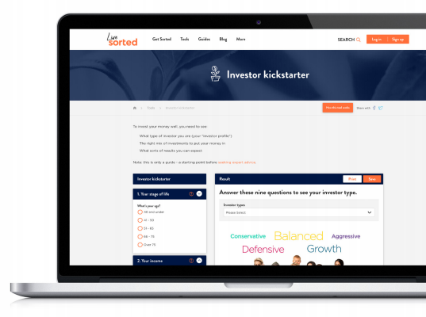

Activities
- With a partner, read through each of the scenarios on this FMA webpage and discuss why the investment options each person has chosen are a good mix for their investor profile.
- Choose one of the characters you invented in Topic One. Choose an investment option for them and analyse its suitability by considering:
- the timeframe that the investment is for and whether they can access these funds before maturity
- how much you need to invest
- the risks of the investment
- the expected or potential returns of the investment
- costs related to the investment, for example, any fees they would have to pay.
Justify your reason for choosing that investment option for them. You may need to invent some further details about their goals or circumstances. Check your analysis and justification with your teacher.
- Re-watch the Future Focus video. Create an investor profile for Simon and Leila. What investment options would you recommend for Sapphy and Corinne?
Before moving on to your assessment, check that you understand:
- how to use the Sorted.org.nz Investor kickstarter tool
- how to choose investment options that are a good match for different individual investor profiles
- how to justify your recommended investment options based on their level of risk, return, and timeframe.

Ka pai!
You’ve completed the Investment Options module. Use the checklist below to make sure that you are ready for your assessment.
Checklist for US 28095 Analyse personal financial investment options
I can:
- explain what an investment profile is
- use the Sorted.org Investor kickstarter to determine a character’s investor type
- analyse KiwiSaver and at least one other investment option in terms of their:
  - costs
  - timeframe
  - how much is needed to invest
  - risks
  - returns.
- identify which investment option best suits a person’s investor profile
- justify why an investment option is a better choice than another investment option.

Reference list

Student activities | sortedinschools.org.nz/students/activities/
Glossary | sortedinschools.org.nz/api/v1.0/download?filename=investment-options-glossary&files=2393
Investment options module video | vimeo.com/425276406/e1df77ab4b
Sorted.org.nz guide to saving and investing | sorted.org.nz/guides/saving-and-investing/
Sorted.org.nz investor kickstarter tool | sorted.org.nz/tools/investor-kickstarter
Sorted.org.nz Smart Investor tool. | smartinvestor.sorted.org.nz/
Financial Markets Authority (FMA) video | youtu.be/rDqMuMlRXN8
Guide to investor types | sorted.org.nz/guides/saving-and-investing/our-investor-type/
Man with Down syndrome 'dancing' after winning change in KiwiSaver rules | nzherald.co.nz/personal-finance/news/article.cfm?c_id=12&objectid=12251469
KiwiSaver fund types and levels of risk | sorted.org.nz/guides/kiwisaver/kiwisaver-which-fund-suits/
Active or provisional KiwiSaver members in New Zealand | figure.nz/chart/KmJxQe3Wy99SURCA-f2tYAD9vIdcF9unA
KiwiSaver Savings calculator | sorted.org.nz/tools/kiwisaver-savings-calculator
KiwiSaver fees calculator | sorted.org.nz/tools/kiwisaver-fees-calculator
Ethical KiwiSaver investments | sorted.org.nz/must-reads/looking-for-ethical-options/
KiwiSaver Sorted Booklet | sortedinschools.org.nz/api/v1.0/download?filename=kiwisaver-sorted-booklet&files=551
KiwiSaver Pick a Path interactive | sortedinschools.org.nz/students/activities/kiwisaver-pick-a-path/
Government changed the default fund for KiwiSaver investors | stuff.co.nz/business/119885579/govt-tweaks-kiwisaver-settings-to-put-more-money-in-investor-accounts
Sorted guide to investing in shares. | sorted.org.nz/guides/saving-and-investing/shares/
Bank deposits – Investing in bank deposits and savings | sorted.org.nz/guides/saving-and-investing/bank-deposits/
Kiwi Bonds on this Treasury webpage | debtmanagement.treasury.govt.nz/kiwi-bonds
Sorted.org.nz guide to investing in property | sorted.org.nz/guides/saving-and-investing/investing-in-property/
Stuff article about two young property investors. | stuff.co.nz/life-style/home-property/66436561/two-young-property-investors-two-different-strategies

NCEA Level: 2 (version 3)
QAAM Number: #3151

Unit Standard: #28095
Unit Standard Title: Analyse personal financial investment options

