Te Aromatawai Whakawhanake

Māui Rautaki: Te whakatakoto whāinga, te whakamahere

Te Mātaitanga: Pipi Mā

Ko Hohepa Tuahine rāua ko Kristin Ross ngā kaihanga o ētahi taare kōrero Māori tuatahi i te ao mō ngā tamariki, arā, ko Pipi Mā. I kitea e te tokorua nei te maha o ngā whānau kōrero Māori e kaimōhū ana i te iti o ngā rauemi mō ā rātou tamariki. I te tau 2016, hei tuatahitanga i te ao, ka whakarewahia a Pipi Mā - me ngā hokonga tuatahi ake e kīia ana ko te kohinga ‘Kōrero’.
Ka hokona atu ngā taare i te 8 o ngā rā o Whiringa-ā-rangi i te tau 2016, ā, ka hokona katoatia i te 36 haora. I te tau 2017, ka whakarewahia te taupānga ‘Tae’, hei ako i ngā tae ki tā te Māori titiro. He nui noa atu ngā taonga a Pipi Mā hei hoko e tautoko ana i tā rātou aronga reo Māori, arā, he kāri ako, he pukapuka taetae, he tīhāte hoki.
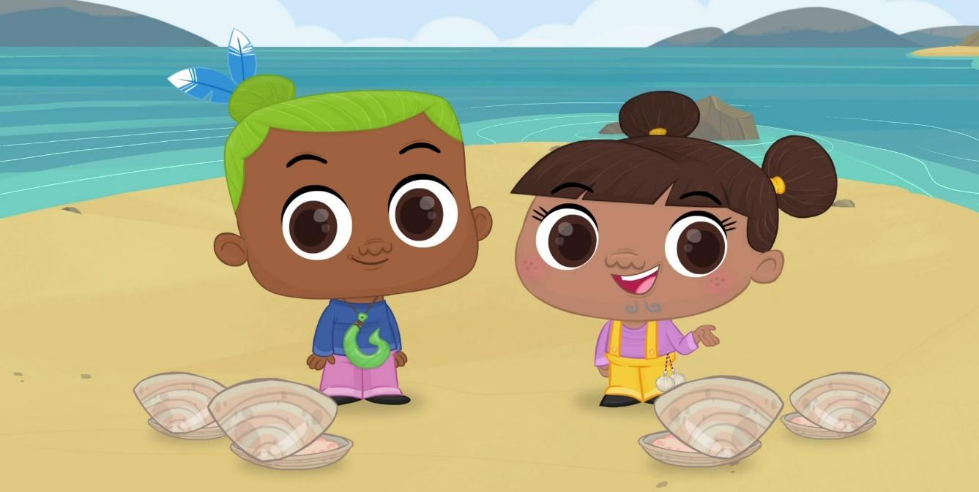

Ngā pātai hei whakaaro māu:
- He aha kē te tikanga o Pipi Mā?
- He aha tā rātou i whakamahere ai kia ea ā rātou whāinga?
- I āta whakamahere rātou mō ngā utu kāore i te mōhiotia?
- He aha āu kupu āwhina kia pai ake ai ngā tukanga i whāia e rātou ki te whakatutuki i ngā whāinga?

Ka mutu ana te kohi i ngā kōrero, whakautua ngā pātai nei:
- He aha ngā mōhiohio i kitea?
- He aha te wāhi ki ngā mōhiohio nei hei āwhina māu ki te whakamahere i tō āpōpō?

He ngohe whakawhānui ake:
- Me matapaki ā-rōpū i te hāngai o te pakirehua nei ki te mārama, ki te pai ake rānei o ngā mōhiotanga me ngā waiaro o te tangata ki te whakarite whāinga ahumoni, me te whakamahere i tōna āpōpō.

https://www.maoritelevision.com/shows/pipi-ma/on-demand
https://www.maoritelevision.com/news/national/entrepreneurs-changing-game-maori-business-innovation

