Investing in shares
Teacher guide

The purpose of this learning resource
- To introduce the basics about shares including, how the share market works, how to choose companies to invest in and put their learning to the test with a share market simulation.
- To apply statistics knowledge that aligns with the New Zealand curriculum to collect and understand share market information.

What are the learning objectives?
- Understand the concept of investing in shares
- Explore by investigating companies’ revenue comparisons and simulate investing in shares

Who is it for?
It is designed for students who are working towards NZ curriculum level 5.

What do I need?
Students needs a computer / chromebook or a handheld device such as tablet. This is not suitable for a mobile (i.e. phone) device.

How can I use it?
- This resource is designed as a cross-curricular resource, supporting one of the Sorted themes, investing.
- This resource can be also used for whole-class instruction and directed teaching for schools that integrate NZC learning areas such as statistics or social science with financial capability concepts.
- This resource allows students to build financial capability knowledge and enables them to work at their own pace.

How does it work?
Group work/Individual: Students can work individually, in pairs or groups.

Prior knowledge
- Student should understand:
  - New Zealand curriculum level 4 to 5 mathematics and statistics knowledge.
    - Use graphs and tables to describe linear relationships found in patterns.
    - Plan and conduct investigations using the statistical enquiry cycle.
  - The vocabulary prior to starting the activity.

Lesson resources – Part I and Part II
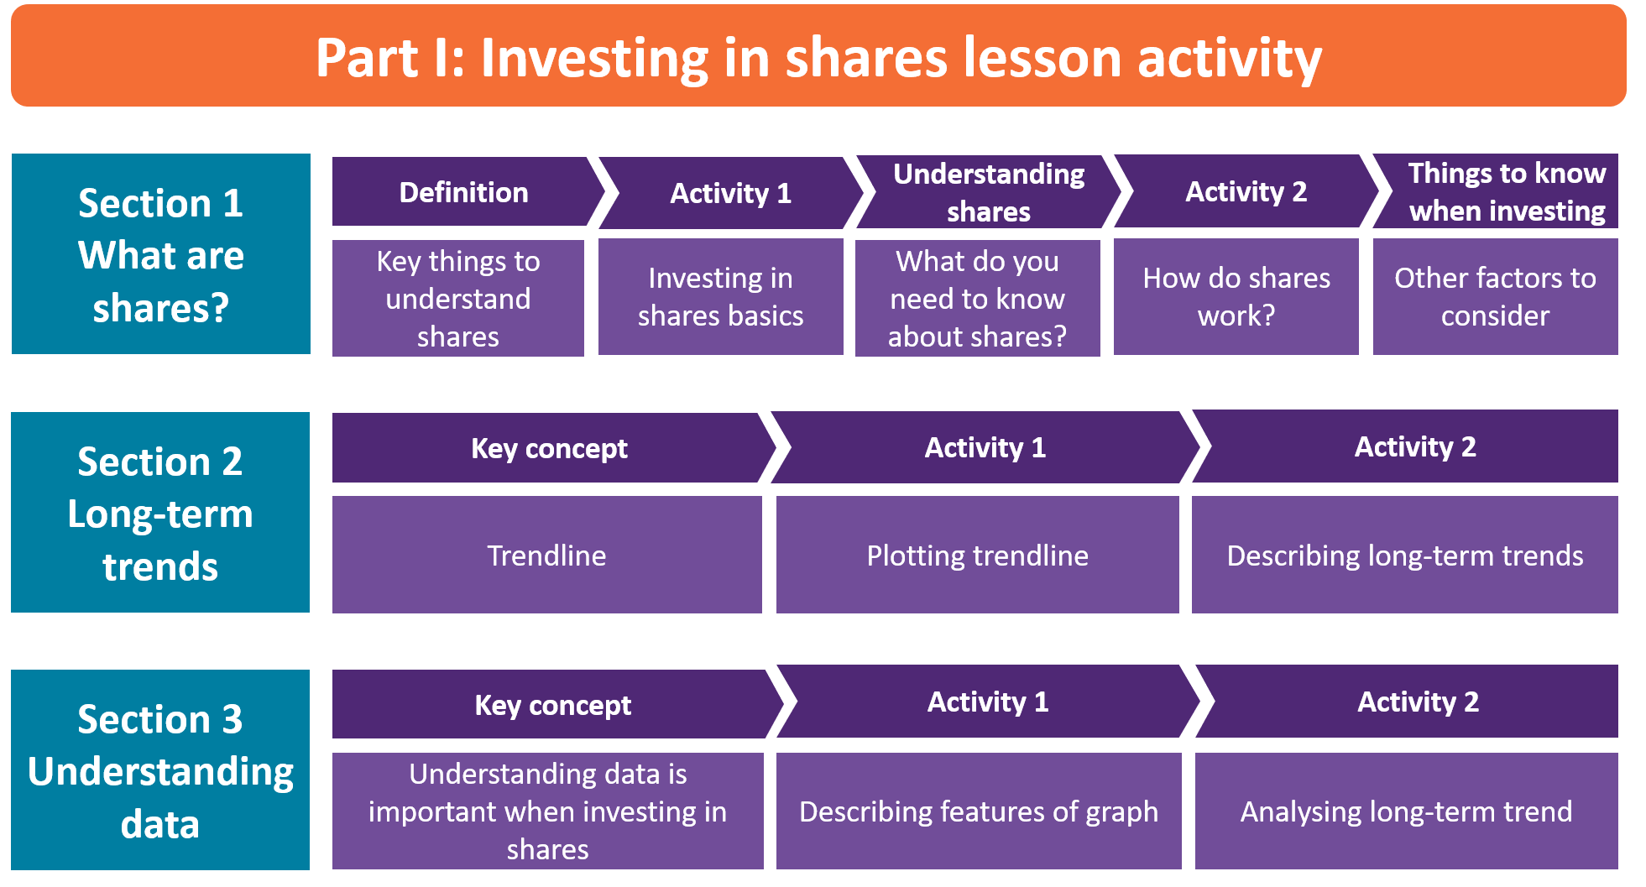
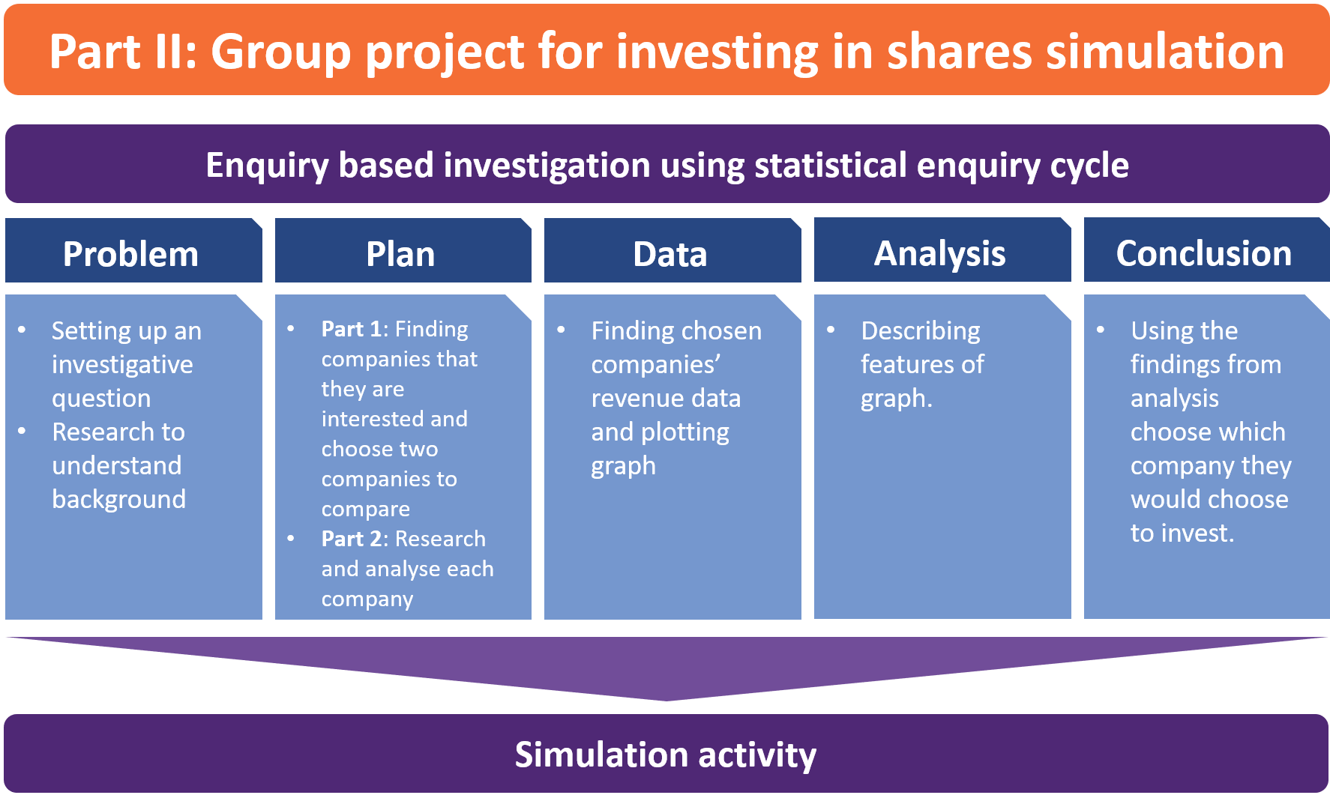
How does this activity link to the Financial Capability progressions?

- Savings & investing: Investigate different investment products as a way of saving (L5)

Financial vocabulary

Investing, Shares, Long-term investment, Capital value, Dividends, Revenue, Performance overview, Risk management, Annul report, Long-term trends, Return

Sorted Themes

In this activity, students are given information and activities that relate to the Sorted Themes. These help students build financial attitudes and beliefs, knowledge, and behaviours specific to each theme.

