WĀHANGA TUARUA: TE WHARE TAPA WHĀ: TE ORANGA TOROWHĀNUI ME TE ĀHEITANGA AHUMONI.
- Ka pēhea te oranga e tūhono ai ki te āheitanga ahumoni?

Te Whare Tapa Whā me te Āheitanga Ahumoni

Nō tā Māui whakapōturi i a Tamanuiterā, ko te nuinga atu o te wā i ia rā te tukunga iho ki a tātou hei rapu i te tauiritenga i roto i tō tātou Whare Tapa Whā. I taea tērā te whakatutuki nā tōna māia i te tuatahi kia mahia e ia te mahi. Nō tōna mōhiotanga ko wai ia, nō hea ia, nō tōna tūnga hoki i te ao taua māia. I mōhio anō hoki me pēhea te whakamahere, me pēhea te whakatakoto whāinga me te whakahaere wā, rawa, tāngata, me pēhea hoki te haumi ki roto i ētahi atu mā te tiritiri i tōna mōhiotanga nunui ki a rātou. He tipua tino māia a Māui. Engari i tua atu e tohu ana ōna āhuatanga i te āheitanga ahumoni.
E aweawetia ana ō mahi whakatau e tō mōhio nō hea koe me tō tūnga i te ao. He wāhanga tino waiwai o te hanga whakatau ko te āheitanga ahumoni kia pai ake ai tō whakahaere me tō haumi moni, tērā ka aweawe pea i tōu oranga me tō tō whānau anō hoki.
Kia pai ake ai tō mōhio ki te āhua e tūhono ana te oranga ki te āheitanga ahumoni, e whakaatu ana te tūtohi i raro nei i ngā pūkenga me ngā āhuatanga o Māui mā te kōrero pūrākau o tana whakapōturi i te rā. E whakaratoa ana he ariā matua i te wāhanga mōhio ahumoni tērā e hura ka pēhea ōna āhuatanga e whai pānga ana ki te mōhio Ahumoni. I te tīwae whakamutunga ka pātaitia koe e te Whare Tapa Whā ki te whai whakaaro ka pēhea pea te pānga takatika o te āheitanga ahumoni ki te oranga torowhānui. Heoi, ehara i te mea kei te tika, kei te hē rānei ētahi huatau.
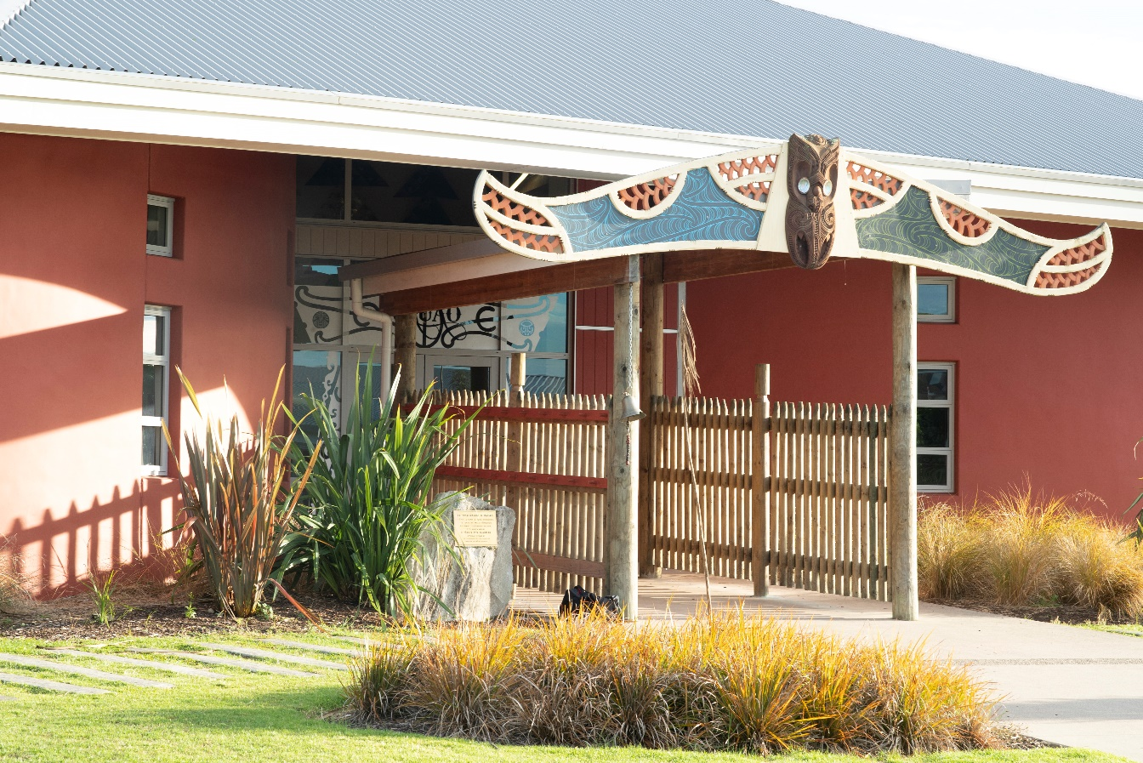

Māui - Mōhio Ahumoni – Oranga

Ngā Huānga Pou i tautohutia ngā āhuatanga o Māui i te pūrākau mō tana whakapōturi i te rā. | Ngā Pou Āheitanga Ahumoni  - Me pēhea te hanga i tētahi mea (moni)  - Me pēhea te whakahaere i tētahi mea (moni)  - Me pēhea te haumi ki roto i tētahi mea (moni), ki tētahi mea rānei (moni)  - Me pēhea te whakarite kia mahi tētahi mea āu (moni) mōu | Ngā Pou o Te Whare Tapa Whā  Me whakamahuki ka pēhea te āheitanga ahumoni e aweawe i te Whare Tapa Whā. Kāore koe e mate ki te whakaoti i ngā pou katoa e whā
Te tino rangatiratanga (e whakapai ake ana i te ao o ētahi atu, me tōu ake ao)  I pūtohe a Māui ki te whakapōturi i te rā kia whiwhi ai te whānau i te nui ake o te wā mō te pāhekoheko hei whānau. | He mea whakahaere e Māui tōna wā, ōna pūkenga me ōna huānga ki te whakatutuki i taua tūmahi.  I pau i a Māui te wā me te kaha ki te whakaoti i te rapanga, me te hanga i ngā otinga whaitake,  tautini anō hoki  I whakamahi a Māui i tōna mōhio ki te hanga otinga, ka mutu, ka ea tāna i tōminamina ai. | Te Taha Whānau:  I whakamanawatia a Māui e te whānau ki te hanga otinga whaitake mō te oranga ki tua
Te Taha Wairua:
I whakamahi a Māui i ngā mōhiotanga taketake pēnei i te karakia ki te ārahi me te uruhi i tērā i tuku iho ki tōna whakatipuranga me ngā mea i whai atu
Te Taha Hinengaro:
I whakamahi a Māui i tōna hiranga hinengaro me tōna pāuaua kia ea ai tōna wawata. Te awhero me te hihiko rāroto
Te Taha Tinana:
Te whakatau ko tōu kotahi i tōu anō whakanaketanga

