He Ngohe Ako 3
‘Taonga’ nā Twilight

Māui Auaha

Wahanga Toru: He Ngohe Ako
Pānuihia te mātaitanga e whai ake nei. He ngohe kei te mutunga hei āwhina i a koe i te ara whai pakihi ake.

‘Taonga’ nā Twilight
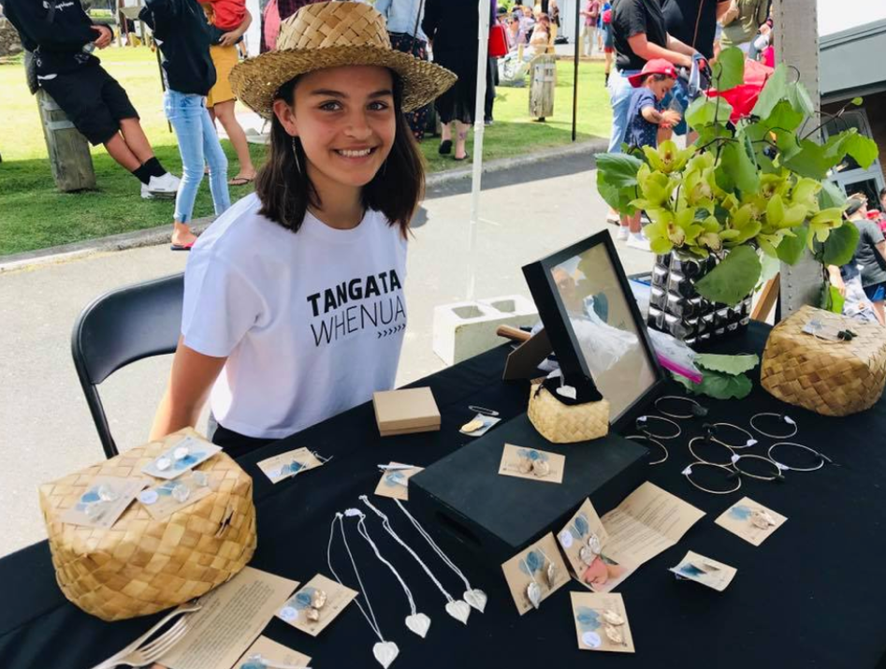

Anei a Twilight e hoko taonga atu ana i tōna ake toa hokohoko, i te Mākete InnoNative, 2017.
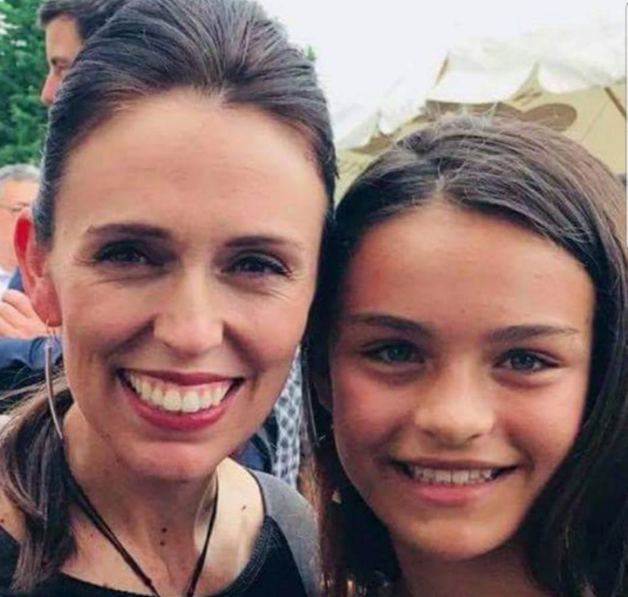
Ko te pirimia a Jacinda Ardern e mau ana i ngā whakakai taringa nā Twilight.
Mārama ake nei a Twilight Edwards ki te whakaaro auaha, te whakamahi i ngā whakaawenga o te taiao me ōna rawa. Whakapakeke mai ana a Twilight rātou ko tōnā pāpā, tōna māmā, tōna tungāne me tōna teina ki te moutere o Motuarohia te motu i tū tōna pāpā hei kaitiaki i ngā tau 10 tau kua hori.
Tīmata ai a Twilight ki te hanga i āna ake taonga (whakarākei), i tana ake ‘waitohu’ me tana kāri pakihi i a ia e 8 tau ana. Kua noho ia hei rangatira i tāna ake pakihi nō tana eke ki te 11 tau. Ko InnoNative te rōpū whakahaere e whakatairanga ana i ngā pakihi Māori, me te toa a ‘Tukau’ e hokona ana i āna taonga.
E mea ana a Kara, te māmā o Twilight, ‘Mai anō tōna auahatanga. I a Twilight e taitamariki ana he hangahanga tana mahi. He hinengaro rakahinonga tōna. Engari anō mō māua ko Hongi, heoi anō ka tautoko atu. I āta whakaritea e māua he taiao auaha i tō mātou whare. I ngā wā katoa ka kitea mai he tūmahi toi, me taku whakaae kia whakamahia e rātou [e āna tamariki] ngā rauemi, ngā rawa o te taiao, i a Hongi e poipoi ana i tō rātou hononga ki te whenua’.
I kuraina a Twilight ki ngā kura maha o te Taitokerau, ā, kua eke ki te 13 tau. Kua hūnuku tōna whānau ki Waimanalo, i Hawai’i, ā, nō reira tōna koroua.

Nō hea te whakaaro hihiko kia tīmatahia tō pakihi ake?
Nōku i te kura i te Tau 4, i te kura o Ngunguru, ka tū tētahi hokohoko toi, ā, ka hangaia e au tētahi kete me ētahi kōmore koura e toru hei tautoko. I a au e takatū ana mō te hokohoko nei ka whakaaro ki te waihanga kāri pakihi, ka puta mai te ingoa ko ‘Taonga nā Twilight’, ā, ka whakatūria taku pakihi ake.

Nā wai koe i āwhina?
Nā taku māmā otirā taku whānau ahau i āwhina. Nā taku matua te hanga o taku tohu i āwhina mai. Nā taku whaea ngā tapanga mō ia taonga i āwhina te tuhi. I tētahi wā ko te whare i nohohei wāhi mahi i ngā taonga whakarākei me ōna tāngata hei kaiāwhina. Hei āpiti ki tōku whānau, i tautokona ahau e te hapori inarā ko te whānau o Te Kāpehu Whetū i kaha te tautoko mai i taku pakihi.

Nō hea hoki āu hoahoatanga?
Ka hoki ngā kōrero mō aku whakakai taringa kawakawa ki taku akomanga konganuku marihi. Ka mea mai te kaiako me tīmata ki ōna hangarewa kōaro, pērā ki te pūrerehua, te manawa me ētahi atu mea kāore i rata ki a au, nā reira kāore au i whakaae. Ka puta au ki waho ki te rapu i ngā rau kawakawa pakupaku, ā, ka kitea. I ākona e au te āhua ā-mahi i taku hononga ki te rau.
Ka pau ētahi marama ka oti tika i a au ngā whakakai tuatahi ki te āhua i hiahia, arā, ki tāku i rata ai. He nui ngā momo kua oti i a au. Ka whakamahia te kōata moana, ngā kōhatu, te harakeke, te aha noa atu. He tini ngā taonga ka riwha i a au, ka riro i a māmā hei whakakai māna, ā, kāore mō te hoko atu. Kāore au i te tino mōhio nō hea rawa ngā whakaaro. He rerekē ia taonga. I ētahi wā ka tono mai te tangata kia hangaia mai tētahi mea, ā, ka toko ake tētahi whakaaro ki te āhua o tētahi taonga anō.

He wā i whakaaro kia tukuna tēnei kaupapa kia mate noa?
Āe

He aha ai?
Nā te mea i ētahi wā ka hongehongeā te hokihoki ki te mahi kōtahi. Ko te mea pai ki a au, ko te rāwekeweke i ngā āhua ā-mahi hou me ngā rawatoi hou. Ko te nuinga o aku hanganga kāore e tutuki, heoi anō he rawe katoa ki a au te waihanga me te whakamātautau. He uaua rawa te kawe i ngā mahi o te kura, o ngā hākinakina, o te whānau, me te whakariwha i ngā tono whakarākei. Ka tohutohu mai ōku mātua ki te mahi i ngā mahi hāpai i te whare ahakoa te nui o ngā tono. Kei te mārama pai te nuinga o aku kaitono, ā, ka manawanui rātau. I pēnā i te wā o taku whakaaturanga pūtaiao me aku whakamātautau.

He aha rā ngā tūāhua e akiaki ana i a koe kia ū tonu?
Ka whai tono ana, ā, kua utua e te tangata, me kaua au e mate wheke. Me oti i a au, me tae atu ngā taonga ki a rātou. Ka āwhina mai taku whānau kia ū tonu au ina pau ana taku hau. Ka āwhina mai taku tungāne, taku teina me ōku mātua. Ko ngā nohinohi ka āwhina ki te whakamāene i ngā taonga i a rāua e mātaki pouaka whakaata ana. Mā taku māmā ngā tono me ngā īmera. Ki te nui te mahi, mā taku pāpā te konganuku e tapahi.

Ko whea koe hei te 10 tau e tū nei?
Ki ōku whakaaro he pakihi rerekē tāku. Kāore au i te tino mōhio he aha rā tērā engari he kaupapa auaha. He kaupapa e rērere haere ai ahau ki te ao.

He aha ō moemoeā mō tō pakihi hei ngā tau e tū mai nei?
I a mātou i Hawai’i i te tau nei ko te tumanako ka hihiko anō te ngākau ki ngā whakaaro hou. He ako i ētahi māhi ā-āhua hou. E tino hiahia ana ki te whanake ki te ao hoahoa kākahu, ki te hanga kākahu, hanga pēke, hanga hū me ngā mea whakarawe whare. I tēnei tau kei te hiahia au ki te whakarite i te paetukutuku mō ‘Taonga nā Twilight’. Me tika hoki aku tukanga tono. Ka hangaia e au ia taonga, ā, he roa rawa. He uaua hoki kia tutuki i ngā tono maha. Me kimi ara e tere ake ai te hanga. Kāore i ārikarika ia hanganga, he taonga nā te aroha.

He aha rā ō moemoeā ahumoni ake, ō whāinga, ō wawata mō āpōpō?
Ka ārikarika katoa ahau ina e hokona ana aku taonga huri noa i te ao. Pai ki a au te whiwhi pūtea, engari ko te mea e tino kaingākaunui ana, ko aku mahi toi. He rawe ki a au ka koa te tangata i aku hanganga, ā ka pā ki ō rātou ngākau, ki ō rātou tuakiri tonu.

He aha ētahi kupu āwhina ki te hunga e whakaaro ana ki te whakatū i ā rātou pakihi ake?
Kei mate wheke noa, kia ū i ngā wā uaua. I kuhu atu ahau ki te hōtaka Hine Boss, ā, he tino rawe. I āwhina i a au ki te whakarite i taku mahere pakihi, i ako ki te tiaki i aku pūtea, ā, he nui ngā kupu āwhina o te katoa i roto i te akoranga. I āwhinatia ahau ki te whakarite tika i ngā utu, ā, nā whaea Moana ahau i āwhina ki te whakarite i taku tukanga tono. He nui tonu ngā rawa e wātea mai ana ki a tātou i Aotearoa me tō tātou waimarie hoki. Ki te hanga i tētahi mea e rata ana ki te iwi, ka pā ki ō rātou ngākau, ā, ka tautoko atu, ka hoko i ngā taonga. Ka nui taku whakawhetai ki ngā tangata maha i āwhina mai, i whakaako mai, ā, e tautoko tonu ana mai.
Ka whakatairanga a Twilight i tana pakihi a ‘Taonga nā Twilight’ i tana whārangi pukamata nāna i whakarite, ā, e tō mai ana i te hunga hokohoko. I tētahi marama kotahi, atu i te Whiringa-ā-rangi tae atu ki te Hakihea 2018, i eke ngā te wāriu o ngā hokonga ki te $10,000 neke atu. “i pokea katoatia i taua wā heoi anō kua māmā ake i nāianei, me te pai hoki!”!”

He Ngohe Ako
Kua mutu tō pānui i te mātaitanga nei. Tēnā whakaarohia ngā pātai e whai ake nei
- Kua whakaaro rānei koe ki te kōkiri i tō pakihi ake?
- Mēnā koe te whakatū i tō pakihi ake, he aha rā te momo pakihi?

Hei mahi:
Tēnā tuhia, hopukia rānei i te 10 meneti te nui o ngā whakaaro e pā ana ki ngā tū pakihi ka taea.

He pātai hei whakaaroaro:
- He aha ngā kaupapa e kaingākaunuitia ana, e rata ana rānei ki a koe?
- He aha ō pūkenga, ō mātauranga? He aha hei ako māu?
Ka whakaaro rānei koe ki te waihanga taputapu hei hoki, ki te whakatū ratonga rānei mā tāngata kē?

