Rārangi take

Māui Ihumanea Te Whakatānga me te KiwiSaver 1
He Kupu Whakataki 1
He Whakamārama 2
KiwiSaver He Whakamārama Poto 4
Māui Ihumanea Te Ngohe Whakatānga 1 8
Māui Ihumanea – Te Ngohe Whakatānga 2 13
Māui Ihumanea: Te Ngohe Whakatānga 3: 16
Māui Ihumanea Te Aromatawai Whakawhanake mō te Whakatānga 19
Te Ngohe 1 o te Aromatawai Whakawhanake: 20
Te Ngohe 2 o te Aromatawai Whakawhanake: 22
Te Ngohe 3 mo te Aromatawai Whakawhanake: 23

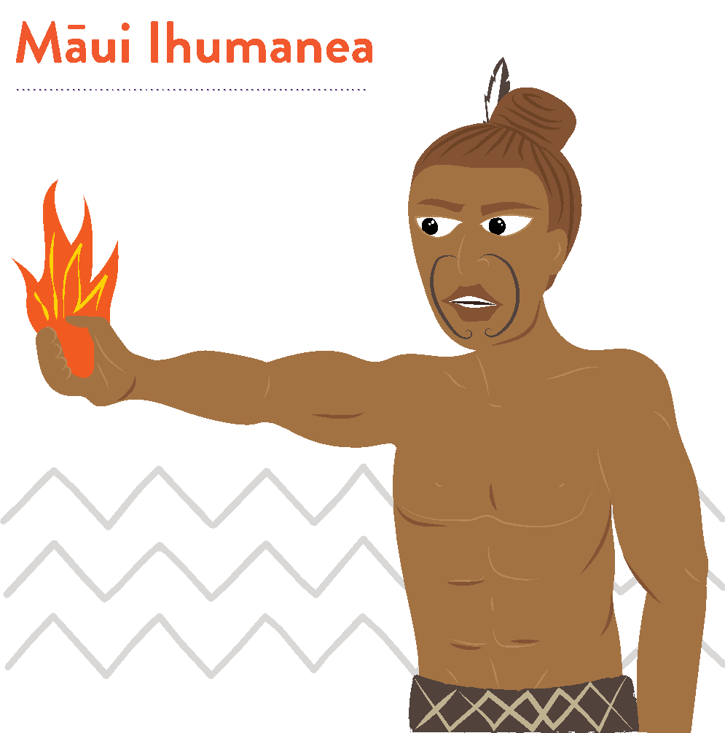

‘Kia pārekareka tō anamata’
Māui e mārama ana me pēhea te whakamahi
i ngā mahi hei painga mo ngā rā o mua.

Māui Ihumanea Te Whakatānga me te KiwiSaver

He Kupu Whakataki
I roto i tēnei rauemi, ka tirotiro tātou i te whakatānga, i te Kiwisaver hoki,
he momo penapena whakatānga me te ahunga haumitanga.
Ko te whāinga o tēnei rauemi, he whakaako i ngā tikanga Māori, ā, e pēhea
ana te hono ki te ariā whakatānga.
Ngā ngohe hei āwhina i a koe ki te tātari i nga ariā, hei awhina hoki i a koe
e mārama ai ki te matua nui o to timata ki te whakaaro mo to whakatānga
ināia tonu nei.

E 3 ngā ngohe whakatānga mō ngā ākonga:
- Māui Ihumanea: He Ngohe Whakatānga 1 – Hinengaro: Mahere ahunga pae tawhiti
- Māui Ihumanea: He Ngohe Whakatānga 2 - Kua Mutu Te Mahi: Pēhea ana rā te haere o te pūtea penihana o Niu Tīreni?
- Māui Ihumanea: He Ngohe Whakatānga 3 - Te Whakamahere mō te Whakatā

Kōtahi anō hoki te:
Aromatawai whakawhanake mō te whakatā
Puka tautoko: Te Puka Whare Tapa Whā

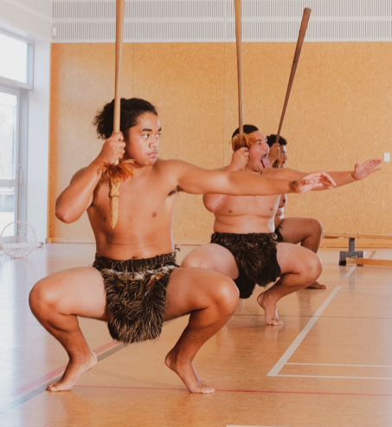
He Whakamārama
Ka whakatā te tangata i te wā ka whakaaro ia me mutu tana mahi, ka hāneanea tana noho. 65 tau te tai pakeke tika ki te whakatā i Aotearoa. Heoi, he tokomaha ka mahi haere tonu i tua atu
o te 65 tau.
Ki te whakatau te tangata kia mutu tana mahi, me pēhea tā rātou utu tonu i ngā mea pēnei i te hiko, te waea pūkoro, te rēti, mōkete rānei.
Me pēhea te tangata e mohio pū ai, ka reri rātou ki te whakatā, iti noa te aro ki te moni, hei waha māna, mā te whānau.
I roto i tēnei hōtaka whakaako, akoako, ko nga tikanga Māori, me ētahi atu ariā whakatānga ka matapakihia.
Ka tirotirohia e tātou te Kiwisaver hei ara penapena mo te whakatā, hei ahunga haumitanga mā te whānau mo ngā ra kai te haramai.
Nō te whakaāta haeretanga o te ra i a Māui, he nui atu ngā haora i tākohangia ki
te tangata, i nui ake ai ngā haora hei whakatō māra, kohi kai, a, ka mōhio haere,
ka mārama haere nā ngā akoakoranga tiaki i te whānau. Nā tēnei anō hoki, ko ngā kaumātua ngā pātaka pupuri kōrero matua, ngā kaitiaki tamariki, kaiwhakaako mokopuna, kua kore ngā momo mahi whakaheke werawera, i noho toiora tonu ai te whānau.
Ko te āhua nei he momo mahere whakatā pea tēnei, i hangaia kia mau tonu ai ki
te oranga tonutanga o te whānau, te tai ōhanga matua i te wā o ngā kuia koroua. He mahi tā tēnā tā tēnā, e ora tonu ai te whānau. Mā te mahi ā whānau mai te wā
e tamariki ana, e whai whēako ai ngā kaumātua hei whakaako i ngā mokopuna.
Nā, ngā mātauranga me ngā māramatanga i ako ngā kaumātua, he mea tuku iho
ki te whānau, ki ngā mea tamariki i roto i te whānau.
I ēnei rā, ka mahi moni te tangata hei whakaatu i o rātou pūkenga, whēako, māramatanga. Koinei ngā moni hei manaaki hei tiaki i te whānau. Ko ētahi ka tākoha ki tetahi mahere whakatā pēnei i te KiwiSaver, me te whakarite KiwiSaver mā ā rātou tamariki ka whānau mai ana. Iti noa ana te tākoha pūtea ki te KiwiSaver, kia whai mahi tūturu ra anō te tangata. Ahakoa tonu, kei te tangata te tikanga e hia te nui o tā rātou utu ka tākohangia ki te KiwiSaver ia wā ka utua rātou.
Kei whakaaro koe kua rite koe ki te penapena moni mo to whakatānga, heoi, ko te tino māramatanga ki te whakatānga, me tīmata koe ki te whakaata, ki te whakamahere i to āhuatanga noho e hiahiatia ana e koe mo to whakatānga. Me whakaaro koe he koha tēnei ki a koe anō, ki to whānau hoki, mo ngā ra kai te heke mai.

KiwiSaver He Whakamārama Poto
He ngāwari he māmā noa iho te KiwiSaver hei penapena mo te whakatā. Pēnei te mahi a KiwiSaver anei hoki ngā āhuatanga matua.
He aha te KiwiSaver?
He kaupapa penapena tūao i whakatūhia e te kawanatanga hei awhina i ngā tāngata o Niu Tireni ki te penapena mo tō rātou whakatānga.
Kai a koe te tikanga ki te koha 3%, 4%, 6%, 8% 10% rānei o to utu (i mua o te tāke) o to utu kaimahi ki ta tātou KiwiSaver. Me koha anō hoki to rangatira – kia eke te 3% o to utu kaimahi.
I te taha o te tākoha KiwiSaver a tō rangatira, he tākoha KiwiSaver tā te kāwanatanga ia tau.
Ka haumingia o pūtea e te kai tuku KiwiSaver e hiahia ana koe. Ki te kore koe e kōwhiri kai tuku KiwiSaver, ka tohua tētahi o te tokoiwa o ngā mahere KiwiSaver
ā te Tari Tāke.

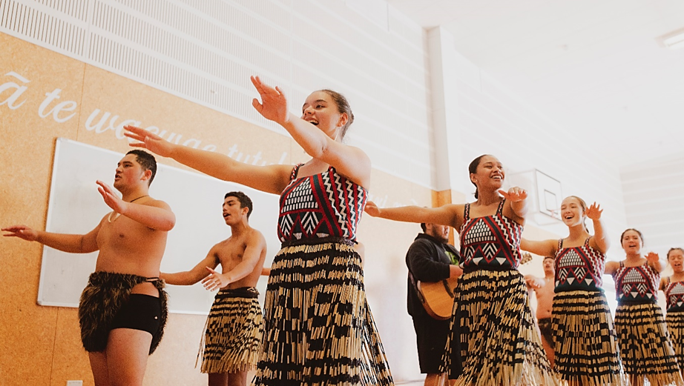

Ko wai ka ahei ki te KiwiSaver
Ka āhei koe ki te KiwiSaver ahakoa kāore anō koe kia whai mahi, hāunga:
- He tangata whenua koe o Niu Tireni, kua whakaaetia kia noho ki Niu Tireni mo ake tonu atu.
- Kai Niu Tireni e noho ana, noho tonu ai ki Niu Tireni.
- Kai raro iho i te tai pakeke e whakaaetia ana mo te pūtea penihana o Niu Tireni (hei tēnei wā e 65 tau)
Mo etahi atu korero, who can and can’t join KiwiSaver kei runga i te pae tukutuku a te Tari Tāke.

Me pēhea te hono atu ki te KiwiSaver
E toru ngā ara ki te KiwiSaver:
- Uru tonu atu koe ka tīmata ana te mahi hou
- Ka kore, mā to rangatira mahi rānei
- Ka kore, mā tētahi atu kaiwhakahaere KiwiSaver

Hunga mahi ā-kiritanga? Kāore he mahi? Kāore he raruraru – whakapā atu ki tētahi kaiwhakahaere KiwiSaver, ki te waituhi kātahi ka whakarite i te rahi o to tākoha. Mo tētahi rārangi kaiwhakahaere KiwiSaver, tirohia te paetukutuku a te Tari Taake KiwiSaver KiwiSaver providers.
Me te aha, mo ētahi atu kōrero, hono atu ki te how to join KiwiSaver i runga i te pae tukutuku a te Tari Taake KiwiSaver.

Nga Painga o te KiwiSaver
Ko te pātai kia uru ki te KiwiSaver he iti, ‘he aha ai?’ he nui atu ‘he aha i kore ai?’ na ngā painga tāpaenga.
- Ngā tākoha KiwiSaver puta mai ai i to utu i mua o tó kitenga. Mā tēnei ka māmā te penapena moni.
- Mēnā kua whaimahi, to rangatira me tākoha i te 3% mai i te katoa o to utu ki roto i to pūtea KiwiSaver. Kai runga ake tēnā i āu ake tākoha.
- Ka utu anō hoki te Kāwanatanga ki tō pūtea KiwiSaver – he tākoha ā-tau (mehemea he mema tākoha koe, kua tekau mā waru tau, koni atu rānei) tae atu ki te $521.
- Hāunga anō te penapena mo te whakatā, ka āhei koe ki te whakamahi KiwiSaver hei hoko i to whare tuatahi mā te pūtea tuku KiwiSaver HomeStart me te hoko whare tango pūtea.
- Ki te whai mahi atu anō koe, ki te mutu rānei te mahi, ka whai atu to KiwiSaver i a koe.
- Mēnā ka uaua ka āhei te tiki atu i o moni i roto i to pūtea moni.

He pehea te mahi a te KiwiSaver?
Ehara i te mea me uru koe ki te KiwiSaver. Engari, me 18 to pakeke neke atu rānei, kua tīmata te mahi hou, kua honoa atu koe ki te KiwiSaver (heoi anō ētahi āheinga). A kāti he mea pai tēnā!
Pēnei ai te mahi a te KiwiSaver:
- Mēnā i uru noa atu koe, he pai noaiho to puta mai (hei aha te KiwiSaver), engari i waenganui i te rua me te waru wiki o te tímatanga mahi. Ka uru atu koe, me tākoha mo te 12 marama. (Mea 18 tau, i raro iho rānei, ā, i hē te whakauru i a koe, ka āhei tonu koe ki te puta mai mā te Inland Revenue)
- Ka āhei koe ki te uru (ki te KiwiSaver) i te wā e hiahia ana koe – ahakoa uru atu ana koe, kāore koe e āhei ki te puta atu – mā to rangatira mahi, ma te kaiwhakahaere KiwiSaver rānei.
- A koe te kaimahi, ka āhei ki te tākoha 3%, 4%, 6%, 8%, 10% rānei, o tó utu katoa, (i mua i te tāke) ki to pūtea KiwiSaver
- Ka pau ana te 12 marama ki te KiwiSaver, ka āhei koe ki te whakatā mai i te penapena, (e kii ana he whakatārewa penapena) me haere tonu.
Uru atu ana koe, ka āhei te tākoha tūao (kākati pūtea, utu auau rānei) kai i a koe te tikanga, ki to kaiwhakahaere pūtea KiwiSaver, ma te Tari Taake rānei. Guide to managing my KiwiSaver account

Te hoko whare tuatahi
Ka hoko koe i to whare tuatahi, ka āhei koe ki te tango i te nuinga o to KiwiSaver mo taua wā noaiho – mēnā kua toru tau koe e tākoha ana ki te KiwiSaver. Tērā pea ka āhei hoki koe me kua whai rawa koe i mua ra.
Hāunga te tango moni mai i te KiwiSaver, ko te pūtea tākoha a te KiwiSaver Homestart tētahi. Ki te whakaaetia, tērā pea ka hoatu e te Kāwanatanga he $5,000 te nui ki te hoko whare tawhito, ka kore he $10,000 ki te hoko whare hou, whenua rānei hei whakatū whare hou ki runga.
Toro atu ki te paetukutuku Housing New Zealand mo ētahi atu kōrero.
Te penapena pūtea mō te whakataa
Mehe kai te whakamahi KiwiSaver hei penapena mo te whakatānga, kaore koe e āhei ki te whāwhā atu i o moni, kia eke ra anō koe ki te tau ka whiwhi koe i to pūtea penihana o Niu Tireni New Zealand Superannuation, ara, 65 tau. Ngā mea kai waenganui o te 60 me te 64 tau, kāore e āhei ki te raweke i ngā moni mo te rima tau.

Te Kōwhiri Tahua KiwiSaver
Ka āhei koe ki te kōwhiri i te KiwiSaver kai reira o penapena, ka tuku rānei ma to rangatira mahi, ma te kāwana rānei tētahi e kōwhiri mā tātou. Ngā kaupapa KiwiSaver e whakahaerehia ana e ngā kaiwhakahaere pēnei ngā pēke, ngā kamupene haumi, me te aha noa, he maha ngā momo tahua hei kōwhiringa.
Ia tahua, he rerekē ngā momo mea hei haumitanga – pēnei i te moni kuhu pēke, herenga pūtea, hea me ngā rawa. KiwiSaver: which fund suits?

Māui Ihumanea Te Ngohe Whakatānga 1
I roto i tēnei ngohe, ka:
- ako mē pēhea te whakaara ake i te whakaaro pai
- ako ki te whakamahi i tēnei pūkenga hei āwhina i a rātou ki te waihanga whāinga pae tawhiti, pēnei i te whakatā (kua mutu te mahi)

Pērā ki ō tātou tīpuna, ka taurite tonu te māramatanga o Māui Ihumanea ki te uarā/wāriu o te whakaaro pai.
I tutuki ai ana mahi whakahirahira, nā tana kaha whakapono ki a ia anō. Ahakoa ngā kutukutuahi, pērā ki ōna tuākana, kāore nei i tautoko i a ia i te nuinga o te wā. Nā tēnei tūmomo āhuatanga i maha ai ana mahi whakahirahira. Kei te kōrero tonuhia e te tangata ngā mahi tuku iho ā Māui Ihumanea, ā mohoa noa nei.
I roto i te wāhanga Māui Rautaki o tēnei rauemi, Te Whakatakoto Whāinga; ka whakaatuhia ki a koe ngā mātāpono o te waihanga mahere. I roto i tēnei ngohe, ka tirohia e tātou ētahi pūkenga hei awhina i a tātou ki te whakatakoto whāinga pae tawhiti, pēnei i te whakatā.

E whakaara ake ana i te whakaaro pai

Tuatahi: Me aroha ki a koe anō, me whakapono ki a koe anō
He rorirori pea te whakaaro me aroha koe ki a koe anō, engari ka piki ake ō kare
ā roto, ka pai anō koe ki ētahi atu. Ko te pono ki a koe anō, ahakoa taua reo whakatūpato, ko te āhua nei ka whāia e koe kia tutuki i runga i tāu i pono ai.

Tuarua: Karakia ia ata, whakahou, whakaaro pai:
Tuatahi ko te whakahaere karakia ia ata, te whakatinana i ngā whakaaro pai, te whakakapi i ngā mahi ki te karakia ia pō, e rongo ai koe i ngā painga kei roto i a koe. Ka pūmau ki te whakaaro pai, pēnei, ‘He ātaahua ahau, he kerewa au, he pai ahau ki ahau anō, me ētahi atu (tāngata) hoki’ i muri i te karakia i te ata, i mua o te karakia i te pō, ka kaha kē atu te whakaaro i roto i a koe, me tō āhua ki ētahi atu hoki.
Tuatoru: Te āwhina i ētahi atu
Ia ata, oho ake ai koe, e pai ana koe ki te āwhina i ētahi atu. Pēnei i te mahi noa i te mahi, kaua e tatari kia kōrerohia koe, ki te awhiawhi, ki te kihikihi i tō whānau, i āu kararehe, i ō hoa. Ko te awhiawhi, ko te menemene ngā tino tāonga mai i tētahi ki tētahi. Ka pārekareka katoa tātou.
Tuawhā: Ia rā me tika te whakatakoto whāinga:
Me whakarite kia rima ngā whāinga ia rā, a, kia māmā noaiho. Pēnei i te:
- whakapai i tō moenga
- paraihe i ō niho
- heru i ō makawe
- whakarite i o kākahu mō āpōpō
- parakuihi
Whiu, e rima kua oti, kāore anō au kia neke.
Tuarima: Whakatauria, ka whakawhanake pūkenga hou
Ko te painga o tōu rēanga, ko te maha o ngā hapa ka puta i a koutou, kāore noa he aha ki te tangata, nā te mea kei te ako tonu koe. Kapohia, karawhiua! Whakaritea to taurangi ki te mahi i ētahi mahi kāore i pai ki a koe ahakoa mo taua wā noiho. Koia kei a koe ki te mahi i te mahi.
Tuaono: Kia māia

Kāore a Māui i noho i tana kokonga me te whakataruna ki te mahi, i te mea kei pēneitia ia, he rorirori, he heahea ki te kore e ekea e ia. Otirā, he tangata māia kē ia. Kaua e mahue i tētahi whēako i te mea kai te mataku koe, tēnā mahia, ka aha ra.
Tuawhitu: Whakaputaina ō raruraru
Ma te kōrerero i ō raruraru ki tētahi atu e kaha ai koe ki te kōrerorero mo ō āwangawana. Ka wehi tonu te tangata ki te whakaputa i ana raruraru, engari ka pai kē ake o kare ā roto ki te whakaputaina e koe. Kaua e wareware, he hoa ōu.
Tuawaru: Ko koe tonu ā runga!
He tipua a Māui, he tipua hoki koe. Ko koe tonu ā runga, kaore i tua atu i a koe. Ko koe te whakakanōhitanga o ngā tātai kāhui i whakatōpū ai, a, ka puta mai ki a koe. Koinei tāu ki a rātou, engari ki a koe anō, me kaha ake, ko koe tonu hoki ā runga.
Tuaiwa: Noke neke nuku
He mea hanga tō tinana kia neke, ā, ia wā ka neke koe, kai te awhina koe i tō manawa. Kei te awhina hoki koe i tō hinengaro, mā te oreore, mā te harikoa. Whakaritea kia korikori mō te toru tekau meneti ia rā, ā, me te puta anō ki waho.
Tekau: Kai ora, kai pai
He toiora te tinana. E noho pakari tonu ai te tinana, me hauora ngā kai. Me kai pata kai hēki runga paraoa tōhi hei parakuihi kaua ko te inu reka. Me kai hua rākau, kaua ko te rare.
Ma te kaiora e piki ai te ārai mate, ā, e roa ake ai ta tātou noho i runga i te mata o te whenua.

Katoa o ēnei āhuatanga mahi, hei awhi i tō whakatakoto mahere pae tawhiti,
i te mea:
- Ka whakaatu i ētahi paku huarahi whai tikanga hei haratau, kia mau ai
ngā whāinga
- Te hau oranga, taha tinana, taha hinengaro, taha wairua
- Te whakapakari, ki te whakamānawa i a koe e tutuki ai ō whāinga pae tawhiti
- Hei awhi i a koe ki ngā akoranga hou, pūkenga hou, ā, māramatanga hoki

Te Ngohe Whakatānga 1
Kei a koe te wā ināianei ki te whakakikī i te tūtohu i raro iho nei.

Taku Whakaaro Pai
Kaupae | Te Wā Haratau | Ō kōrero, ō whakaaro | E hia ngā wā, kōrero, whakaaro rānei
Tuatahi: Me aroha ki a koe anō, me whakapono ki a koe anō
Tuarua: Karakia ia ata, whakahou, whakaaro pai:
Tuatoru: Te āwhina i ētahi atu
Tuawhā: Ia rā me tika te whakatakoto whāinga
Tuarima: Whakatauria, ka whakawhanake pūkenga hou nei
Tuaono: Kia māia
Tuawhitu: Whakaputaina ō raruraru
Tuawaru: Ko koe tonu ā runga!
Tuaiwa: Noke neke nuku
Tekau: Kai ora, kai pai

He Tauira:
Taku Whakaaro Pai
Kaupae | Te Wa Haratau | O korero,  ō whakaaro | E hia ngā wā, korero, whakaaro rānei
Tuatahi: Me aroha ki a koe anō, me whakapono ki a koe anō | I mua o taku maranga, i te wā e paraihe niho ana au | Taku aroha ki a au anō, taku aroha ki ētahi atu | 10 x
Tuarua: Karakia ia ata, whakahou,  whakaaro pai: | I mua o te moe,  i mua o taku maranga ake i taku moenga i te ata | He ataahua, he kerewa, kei te rata au ki au anō,  ā, ki ētahi atu | 10 x
Tuatoru: Te awhina  i etahi atu | Ki te mōrena atu  ki taku māmā | Ka kī atu au ki a ia, kei te aroha au ki a ia, kātahi ka awhiawhi, ka menemene ki a ia, ā, ka mahi kawhe,  tī rānei māna | I nga wā  ka taea
Tuawhā: Ia ra me tika te whakatakoto whāinga | I te kura, i te kāinga | 1. Whakareri mo te kura  2. Kia harikoa, kia pai  3. Ki te ako i ngā mea katoa ka taea e au  4. Whakarongo ki taku  kaiako  5. Ki te whakangahau i te taha o ōku hoa, ki tōku whānau | Te roanga  o te rā
Tuarima: Whakatauria, ka whakawhanake pūkenga hou nei | I te kura, i te kāinga | Ka taea e au ngā mea katoa, ka mau taku wehi! | Te roanga  o te rā
Tuaono: Kia māia | Te roanga o te rā | Ka whakapātaringia e au mea kāore i te pai ki au. Ka pono tonu taku kōrero. | Te roanga  o te rā
Tuawhitu: Whakaputaina ō raruraru | Me tere tonu | Ka kōrero atu au ki taku parata, i taku māharahara mo tētahi o ōku hoa | I ngā wā  ka taea
Tuawaru: Ko koe  tonu a runga! | Te roanga o te rā | Me harikoa, me whakarongo ki waku mātua, Kaiako, haututū me ōku hoa, me te rekareka ki aku akoranga | Te roanga o  te rā
Tuaiwa: Noke  neke nuku | I ngā wā ka taea | Haututū i te papa tākaro, kapa haka, tākaro pā ringa, omaoma i te whīra | I ngā wā ka taea
Tekau: Kai ora, kai pai | I ngā wā ka taea | He kaiora hei whakakaha  i taku ārai mate. Ka pai taku parakuihi, ka kai hua rākau i tēnei rangi. | I ngā wā ka taea

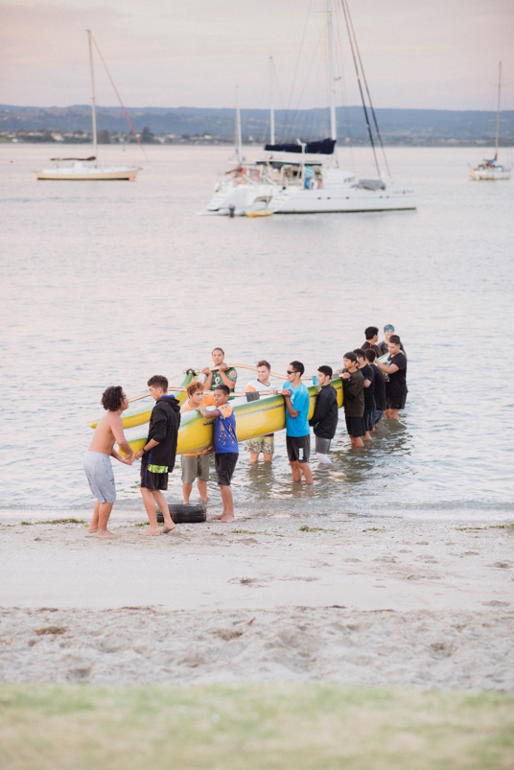
Māui Ihumanea – Te Ngohe Whakatānga 2
He rawaka te rahi o te Pūtea Penihana o Aotearoa mō te whakatānga
Mā ngā ākonga i tēnei ngohe e:
- tautuhi tētahi ritenga Māori taketake e ōrite ana ki te ariā o te whakatānga
- whakamārama haere ki te hira o te whai mahere penapena moni mō te whakatā.

I ngā wā o mua, whakatūria ai he momo mahere whakatānga mō ngā kaumātua. I a rātou e ahungarua ana ka huri haere ā rātou kawenga i te mahi i ngā mahi ā-ringa ki te mahi hei pou herenga mātauranga. Arā, ka noho kē rātou hei kaiatawhai matua mō te hunga tamariki ake, hei kaiako anō hoki mō rātou.
I pau i ngā kaumātua ō rātou oranga katoa ngā whakaakoranga e tika ana te ako, me te whai wheako tērā ka whakawhitia mai anō ki te rangatahi o ngā whānau, mā te tukanga whakawhiti mātauranga i waenga whakatipuranga.
He āhua rite tērā ki tētahi mahere whakatānga e arotahi ana ki te penapena me te haumi moni, engari rawa i aro kē atu ki te whai me te tiaki wheako me te mātauranga. He momo haumi anō ki te whakatipuranga whai ake mā te tiritiri i taua mātauranga ki a rātou. Ahakoa ko te ora o te whānau te take matua, arā kē he ōritenga.
I ēnei rā tonu kitea ai taua ritenga i te maha o ngā whānau. Heoi, he tokomaha ngā kaumātua e whiwhi ana i te Pūtea Penihana o Aotearoa. He penihana tērā e homai ana e te Kāwanatanga o Aotearoa ki ngā tāngata kua eke ki tua o te 65 tau te pakeke. He taupori taipakeke haere te taupori o Aotearoa, me te aha ka uaua haere ake te tohatoha i te Pūtea Penihana o Aotearoa nā te mea e piki tonu ana te tokomaha o ngā tāngata o Aotearoa kua eke ki te tau whakatā i ia tau.
Ko te rahi ka whiwhi te tangata i ia wiki ko te $411. Ki tō whakaaro he nui pea tērā, engari i te ngohe kei raro nei māu e tātai te kounga o te ora mō ētahi o ō tātou kaumātua, i ngā tūāhuatanga ko tēnei tō rātou puna moni whiwhi kotahi.
Te Ngohe 1
He rawaka te rahi o te Pūtea Penihana o Aotearoa mō te whakatānga?
I tēnei ngohe māu e whakaoti te tūtohi i raro me te:
- whakatau mēnā he hiahia me mātua tutuki te utu, mēnā he kōwhiringa noa rānei mō tēnei tangata, i runga anō i te whaiutu
- Me tātai i te pūtea ā-wiki e toe ana, mēnā rā he toenga, mā te tango i te utu whaipainga i te wiki, i ngā utunga rānei mai i te tapeke taumai o te $411

Ka whakautu ai i ngā pātai kei raro i te tūtohi

Mō te taha ki tēnei tangata;
- ka reti i tōna whare noho
- he kaumātua, ka mutu he nui ōna hiahia hauora
- kua whai tāngata i tōna whānau ki te tautoko i a ia
- kua kore e whai motokā, nā tōna kore whai moni hei utu

He rawaka te rahi o te Pūtea Penihana o Aotearoa mō te whakatānga?
Ngā whakapaunga moni ia wiki | Te utu ia wiki  Tapeke whakawaho | 1:  Me utu hei  aha rānei | 2:  $411: Tapeke whakaroto
Riihi | $200 |  | -
Kai | $100 |  | -
Hiko | $40 |  | -
Nga Utu Hauora | $15 |  | -
Waea pūkoro | $10 |  | -
Te tapeke e toe ana ia wiki |  |  | =

Kua takea mai te tūtohi mahere pūtea o runga nei i tētahi kaumātua whakatā e noho ana i Papakura, i Tāmakimakaurau ki te Tonga. Kua tata ki te 80 ōna tau, ā, kua āhua whakatā ia mai i te 65 o ōna tau, me te mahi kōtiwhatiwha i ngā mahi tīpakopako. I ēnei tau e 2 kua pahure ake, e hohe tonu ana ia, engari ka uaua ki a ia ngā mahi ahakoa he mahi hamanga. Heoi anō, e tiaki tonu ana i ana mokopuna, ā, e ai ki a ia ka whakapūhou tonu tērā i a ia.

- Ki tō whakaaro, ko ēhea ngā utu me mātua tutuki, he aha ai hoki?
________________________________________________________________________________________________________________________________________________________________________________________________________________________________________________________________________________________________________________________________________________________________________________________________________________

- Ki tō whakaaro, ko ēhea ngā utu he mea kōwhiringa noa, he aha ai hoki?

________________________________________________________________________________________________________________________________________________________________________________________________________________________________________________________________________________________________________________________________________________________________________________________________________________

- E hia te tapeke e toe ana i ia wiki ki tēnei tangata?

$ _________________

- Ki ō whakaaro, he rawaka tēnei rahinga mō ērā atu utunga ka tūpono mai? Tēnā whakamāramahia mai.

________________________________________________________________________________________________________________________________________________________________________________________________________________________________________________________________________________________________________________________________________________________________________________________________________________

Māui Ihumanea: Te Ngohe Whakatānga 3:
Te Waihanga Mahere mō te Whakatā
I roto i tēnei ngohe, ka;
- Ka marama ake te ākonga he aha e timata moata ai tana waihanga mahere mo te wā mutu ai tāna mahi
- Ka taea te whikawhika i nga tākoha whakatā rerekē

Ko ta Māui Ihumanea ko te whakatakoto whāinga i ngā wā katoa, kia tutuki ai ana hiahia.
I whakaarohia katoahia e ia ngā tikanga, ngā āhuatanga e tika ana, kātahi ka whakamahia ēnei māramatanga e eke panuku ai ana whāinga. E rite tonu ana ki te whakatakoto mahere whakatā, he mea nui ki te whakarite i ēnei momo whāinga.

Whakatakoto whāinga
Ki te whakatakoto whāinga pai, me mārama ki nga painga o te tākoha i te wā e tai tamariki tonu ana.

To āhua i a koe e mahi ana, he paku pēnei
- Tīmata te mahi, te whai te mātauranga (16 - 25 te pakeke)
- Kei te mahi (26 –45 te pakeke)
- Kua tata mutu te mahi/whakatā (46 – 65 te pakeke)

Ā tēnā, e hia noa atu ka taea e koe te penapena mo te whakatānga, ka moata to tīmata. Ka nui te $20 mo ngā whāinga o tēnei ngohe. Heoi anō, ka hiahia rānei koe kia neke atu i te $20 to tākoha. Ka āhei hoki koe ki te whakarerekē i te nui o tō tākoha i a koe e mahi ana, mutu noa. Ka tīmata koe i to $20, engari kia nui kē atu pea, ka rerekē haere hoki ngā āhuatanga e pā ana ki a koe. Tirohia te Tūtohi Mahere Whakatā 1 e whai ake nei, whakautua ngā pātai.

Te Mahere Tūtohi Whakata 1
Pakeke | Tapeke ia wiki | Tapeke (ia wiki, ia tau) 52 wiki
16 ki te 65 tau | $20.00 | 65 -16 = 49 (ngā tau mai te 16 ki te 65 tau)  49 (tau) x 52 (wiki ia tau) = 2548 (tapeke wiki neke atu  i te 49 tau)  2548 x $20 (tapeke tākoha ia wiki)  = $50,960.00
26 ki te  65 tau | $20.00 | 65 - 26 = 39 (tau mai i te 26 ki te 65)  39 (tau) x 52 (wiki ia tau) = 2028 (tapeke wiki  neke atu i te 39 tau)  2028 x $20 (tapeke tākoha ia wiki)  = $40,960.00
46 ki te  65 tau | $20 | 65 - 46 = 19 (tau mai i te 46 ki te 65 tau)  19 (tau) x 52 (wiki ia tau) = 988 (tapeke wiki  neke atu i te 19 tau)  988 x $20 (tapeke tākoha ia wiki)  = $19, 760.00

Ngā Pātai:
- Tautuhia ētahi ‘penapena’ matua rerekē noa mai i te tūtohi i runga ake nei.
a. Whakamāramatia he aha rā te āhuatanga o te mahere penapena moni whakatā, mo te wā roa, mou anō, tō whānau rānei
- Nā, kei a koe. Whakamutua te Mahere Tūtohi Whakataa 2 e whai ake nei
ki te $50.00 tapeke.

Te Mahere Tūtohi Whakata 2
Pakeke | Tapeke ia wiki | Tapeke (ia wiki, ia tau) 52 wiki
16 ki te 65 tau | $50.00 | 65 -16 = 49 (tau mai i te 16 ki te 65 tau)  49 (tau) x 52 (wiki ia tau) = 2548 (tapeke wiki  neke atu i te 49 tau)  2548 x $50 (tapeke tākoha ia wiki)  = $__________
26 ki te 65 tau | $50 | 65 - 26 = 39 (tau mai i te 26 ki te 65 tau)  39 (tau) x 52 (wiki ia tau) = 2028 (tapeke wiki  neke atu i te 39 tau)  2028 x $50 (tapeke tākoha ia wiki)  = $___________
46 ki te 65 tau | $50 | 65 - 46 = 19 (tau mai i te 46 ki te 65 tau)  19 (tau) x 52 (wiki ia tau) = 988 (tapeke wiki  neke atu i te 19 tau)  988 x $50 (tapeke tākoha ia wiki)  = $___________

Māui Ihumanea Te Aromatawai Whakawhanake
mō te Whakatānga

Tatauranga o te uta whakatā, kia pakeke tō haere
He tangata tūpato a Māui Ihumanea, ka whakatakoto mahere e titiro whakamua ana kia hia tau kē ki mua. Nā tana manawanui ki te ako, te whakawhānui ake i te taumata o ana pūkengā, me te hōhonutangā o tana tūāpapa mātaurangā, i āhei ai ia ki te whakaara ake i ēnei whēako mēnā ka hiahia a ia. Koinei te momo mātaurangā ki te whakamahere penapena whakatā.
I roto i tēnei ngohe, ka:
- mārama ki te nui o te piki me te heke o ngā tākoha i te wā e mahi tonu ana ia
- ako ki te whikawhika mahere penapena whakatā

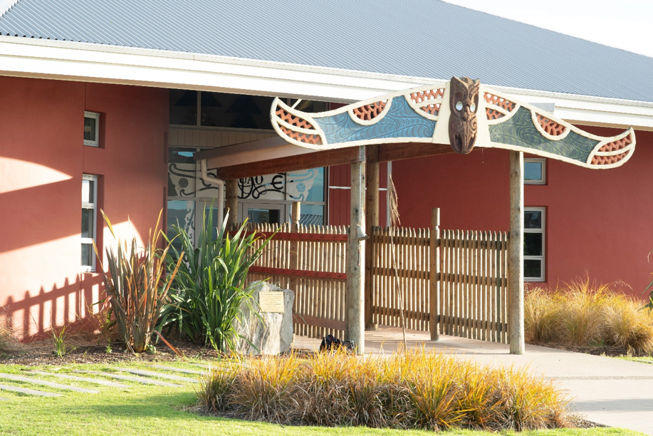

Te Ngohe 1 o te Aromatawai Whakawhanake:
E āhua pēnei ana to āhua i a koe e mahi tonu ana:
- Tīmata ki te mahi/ko te mahi ko te ako tonu rānei (i ngā tau 16 - 25)
- Mahi (i ngā tau 26 – 45)
- Kua tata te whakatā/whakatā (i ngā tau 46 - 65)
Ka pakeke haere koe i a koe e mahi tonu ana, ka rerekē haere ano ngā āhuatangā e pā ana ki a koe. Pēnei i te:
- whakawhanaungā ki tētahi atu, ka noho mā kōrua tahi e utu ngā nama/pire
- whiwhi tohu pōkai rua, tohu paetahi rānei
- whakawhānau tamariki, whāngai rānei
- piki haere o te utu i te nui haere o ngā whēako kua whiwhi i roto i to mahi
- hoko rawa pēnei i te whare, i te motukā rānei
- te hangā whare i rungā papakāingā, whenua whānau rānei
Ahakoa pēhea te rerekē haere o tōu ao, ka pērā anō te āhua o tō hiahia ki te takoha pūtea ki te mahere whakatā.
Ko ngā mahere whakatā penapena pai rawa atu ko ērā e aro ana ki ngā rerekētangā o tōu ao.
I roto i te Mahere Tatauranga Whakatā 1, tatauria ngā wāhi kei te ngāro. Kātahi ka whakautu i ngā pātai e whai ake nei:

Mahere Tatauranga Whakatā 1
Tau | Te nui ia wiki | Tapeke 52 wiki (ia wiki, ia tau) | Whakatakotoranga Whārite
16 ki te 26 tau | $50.00 | 26 -16 = 10 (ngā tau mai i te 16 ki te 26 tau)  10 (tau) x 52 (ngā wiki ia tau)  = 520  520 x $50 (te takoha ia wiki)  = $__________ | 26 -16 = 10 x 52 =  520 x 50  = $__________ = A
26 ki te 46 tau | $150.00 | 46 - 26 = 20 (ngā tau mai i te 26 ki te 46 tau)  20 (tau) x 52 (ngā wiki ia tau)  = 1040  1040 x $150 (te takoha ia wiki)  = $___________ | 46 - 26 = 20 x 52 =  1040 x $150  = $___________ = B
46 ki te 65 tau | $250.00 | 65 - 46 = 19 (ngā tau mai i te 46 ki te 65 tau)  19 (tau) x 52 (ngā wiki ia tau)  = 988  988 x $250 (te takoha ia wiki)  = $___________ | 65 - 46 = 19 x 52 =  988 x $250  = $___________ = C
Tatauria te nui o te tapeke penapena whakatā,  ma te whakatakotorangā whārite e whai ake nei,  ka tuhi ai ki te pouaka i te taha nei  A + B + C = Y |  |  | $_____________ = Y

Te Ngohe 2 o te Aromatawai Whakawhanake:
Mēnā kei te ora tonu tēnei tangāta kua waru tekau mā rima tau te pakeke, e hia te nui o te moni ka whiwhi ia mai i te pūtea kua oti i a ia te penapena. Whakaotia te Tūtohi 1 i raro iho nei.

Tūtohi 1
85 - 65 = 20 (ngā tau mai i te 65 ki 85)  20 (tau) x 52 = 1040 (te nui o ngā wiki mo te 20 tau)  Whakawehea mā te tapeke penapena whakatā  $ ________________ Y  = $ ________________  To utu whakatā ia wiki, ki te ora tonu koe mō te rua tekau tau i muri i tō whakatāngā. | 85 - 65 = 20 x 52  = 1040 / Y = $  ________________

- Kei te pai rānei, kei te kino rānei tēnei nama ia wiki mō te tangata 85 te pakeke? Whakamāramatia mai he aha i pēnei ai o whakaaro.
____________________________________________________________________________________________________________________________________________________________________________________________________________________________________________________________________________________________________________________________________________________________________________________________________________________________________________________________________________________________________________

- E hia tō utu ia wiki mo to whakatānga?

$ _________________

Te Ngohe 3 mo te Aromatawai Whakawhanake:
He rangatahi koe, kei te rēanga tika ki te tīmata wawe i tō whakarite mahere whakatānga. Ināhoki, he mea nui te whakaaroaro māu ki o whāingā whakatā.
Nā, kua āhua mōhio nei koe me pēhea te nui o te tahua ka whiwhi koe ia wiki i to whakatānga, i roto i te Tauira Tūtohi Whakakitenga i raro nei, tuhia ētahi mea e ngākaunuitia ana e koe, e mahi moni ai koe. Ki te pouaka taurite, tuhia ētahi huarahi e whakatinanahia ai ō whakaaro. Kāore he whakautu tika, whakautu hē rānei, nōu te ao.

Tauira Tūtohi Whakakitengā
Ngā mea e ngākaunuitia ana e au, e mahi moni ai au, ka penapena mō taku whakatānga | Pouako Taurite  Whakaputa whakaaro e tinana ai tēnei kaupapa
Hei tangāta whakatangitangi puoro rongonui | - Ka mutu te kura ka ekea te NCEA mō te puoro  - Kia hanga i tōku ake hōngere tiriata, hei paetuku i ngā waiata hou, te whakatū tira whaiwhai  Mā te moni ka whiwhi ahau, ka hoko whare, ka penapena moni ki te KiwiSaver

To Tutohi Whakakitengā
Ngā mea e ngākaunuitia ana e au, e mahi moni ai au, ka penapena mō taku whakatānga | Whakaputa whakaaro e tinana ai tēnei kaupapa

