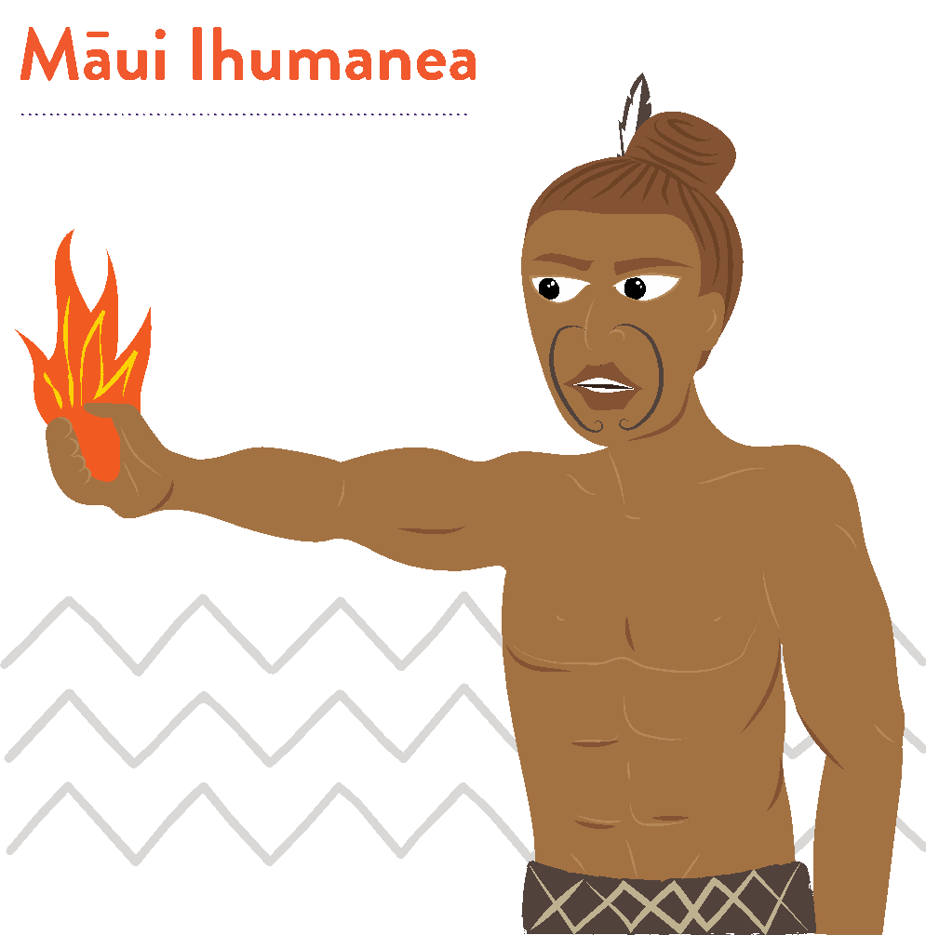

‘Kia pārekareka tō anamata’
Māui e mārama ana me pēhea te whakamahi
i ngā mahi hei painga mo ngā rā o mua.

Māui Ihumanea Te Whakatānga me te KiwiSaver
He Kupu Whakataki
I roto i tēnei rauemi, ka tirotiro tātou i te whakatānga, i te Kiwisaver hoki,
he momo penapena whakatānga me te ahunga haumitanga.
Ko te whāinga o tēnei rauemi, he whakaako i ngā tikanga Māori, ā, e pēhea
ana te hono ki te ariā whakatānga.
Ngā ngohe hei āwhina i a koe ki te tātari i nga ariā, hei awhina hoki i a koe
e mārama ai ki te matua nui o to timata ki te whakaaro mo to whakatānga
ināia tonu nei.

E 3 ngā ngohe whakatānga mō ngā ākonga:
- Māui Ihumanea: He Ngohe Whakatānga 1 – Hinengaro: Mahere ahunga pae tawhiti
- Māui Ihumanea: He Ngohe Whakatānga 2 - Kua Mutu Te Mahi: Pēhea ana rā te haere o te pūtea penihana o Niu Tīreni?
- Māui Ihumanea: He Ngohe Whakatānga 3 - Te Whakamahere mō te Whakatā

Kōtahi anō hoki te:
Aromatawai whakawhanake mō te whakatā
Puka tautoko: Te Puka Whare Tapa Whā
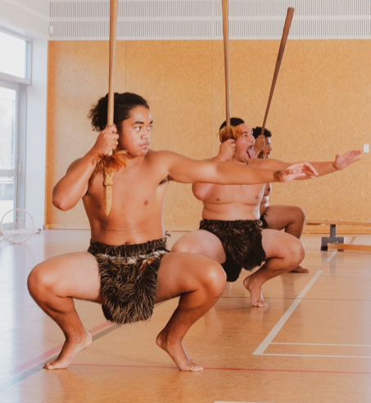
He Whakamārama
Ka whakatā te tangata i te wā ka whakaaro ia me mutu tana mahi, ka hāneanea tana noho. 65 tau te tai pakeke tika ki te whakatā i Aotearoa. Heoi, he tokomaha ka mahi haere tonu i tua atu
o te 65 tau.
Ki te whakatau te tangata kia mutu tana mahi, me pēhea tā rātou utu tonu i ngā mea pēnei i te hiko, te waea pūkoro, te rēti, mōkete rānei.
Me pēhea te tangata e mohio pū ai, ka reri rātou ki te whakatā, iti noa te aro ki te moni, hei waha māna, mā te whānau.
I roto i tēnei hōtaka whakaako, akoako, ko nga tikanga Māori, me ētahi atu ariā whakatānga ka matapakihia.
Ka tirotirohia e tātou te Kiwisaver hei ara penapena mo te whakatā, hei ahunga haumitanga mā te whānau mo ngā ra kai te haramai.
Nō te whakaāta haeretanga o te ra i a Māui, he nui atu ngā haora i tākohangia ki
te tangata, i nui ake ai ngā haora hei whakatō māra, kohi kai, a, ka mōhio haere,
ka mārama haere nā ngā akoakoranga tiaki i te whānau. Nā tēnei anō hoki, ko ngā kaumātua ngā pātaka pupuri kōrero matua, ngā kaitiaki tamariki, kaiwhakaako mokopuna, kua kore ngā momo mahi whakaheke werawera, i noho toiora tonu ai te whānau.
Ko te āhua nei he momo mahere whakatā pea tēnei, i hangaia kia mau tonu ai ki
te oranga tonutanga o te whānau, te tai ōhanga matua i te wā o ngā kuia koroua. He mahi tā tēnā tā tēnā, e ora tonu ai te whānau. Mā te mahi ā whānau mai te wā
e tamariki ana, e whai whēako ai ngā kaumātua hei whakaako i ngā mokopuna.
Nā, ngā mātauranga me ngā māramatanga i ako ngā kaumātua, he mea tuku iho
ki te whānau, ki ngā mea tamariki i roto i te whānau.
I ēnei rā, ka mahi moni te tangata hei whakaatu i o rātou pūkenga, whēako, māramatanga. Koinei ngā moni hei manaaki hei tiaki i te whānau. Ko ētahi ka tākoha ki tetahi mahere whakatā pēnei i te KiwiSaver, me te whakarite KiwiSaver mā ā rātou tamariki ka whānau mai ana. Iti noa ana te tākoha pūtea ki te KiwiSaver, kia whai mahi tūturu ra anō te tangata. Ahakoa tonu, kei te tangata te tikanga e hia te nui o tā rātou utu ka tākohangia ki te KiwiSaver ia wā ka utua rātou.
Kei whakaaro koe kua rite koe ki te penapena moni mo to whakatānga, heoi, ko te tino māramatanga ki te whakatānga, me tīmata koe ki te whakaata, ki te whakamahere i to āhuatanga noho e hiahiatia ana e koe mo to whakatānga. Me whakaaro koe he koha tēnei ki a koe anō, ki to whānau hoki, mo ngā ra kai te heke mai.

KiwiSaver He Whakamārama Poto
He ngāwari he māmā noa iho te KiwiSaver hei penapena mo te whakatā. Pēnei te mahi a KiwiSaver anei hoki ngā āhuatanga matua.

He aha te KiwiSaver?
He kaupapa penapena tūao i whakatūhia e te kawanatanga hei awhina i ngā tāngata o Niu Tireni ki te penapena mo tō rātou whakatānga.
Kai a koe te tikanga ki te koha 3%, 4%, 6%, 8% 10% rānei o to utu (i mua o te tāke) o to utu kaimahi ki ta tātou KiwiSaver. Me koha anō hoki to rangatira – kia eke te 3% o to utu kaimahi.
I te taha o te tākoha KiwiSaver a tō rangatira, he tākoha KiwiSaver tā te kāwanatanga ia tau.
Ka haumingia o pūtea e te kai tuku KiwiSaver e hiahia ana koe. Ki te kore koe e kōwhiri kai tuku KiwiSaver, ka tohua tētahi o te tokoiwa o ngā mahere KiwiSaver
ā te Tari Tāke.

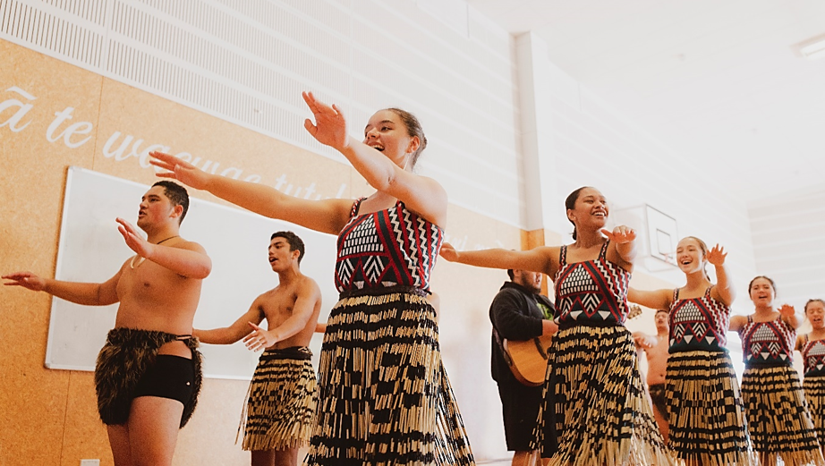

Ko wai ka ahei ki te KiwiSaver
Ka āhei koe ki te KiwiSaver ahakoa kāore anō koe kia whai mahi, hāunga:
- He tangata whenua koe o Niu Tireni, kua whakaaetia kia noho ki Niu Tireni mo ake tonu atu.
- Kai Niu Tireni e noho ana, noho tonu ai ki Niu Tireni.
- Kai raro iho i te tai pakeke e whakaaetia ana mo te pūtea penihana o Niu Tireni (hei tēnei wā e 65 tau)
Mo etahi atu korero, who can and can’t join KiwiSaver kei runga i te pae tukutuku a te Tari Tāke.

Me pēhea te hono atu ki te KiwiSaver
E toru ngā ara ki te KiwiSaver:
- Uru tonu atu koe ka tīmata ana te mahi hou
- Ka kore, mā to rangatira mahi rānei
- Ka kore, mā tētahi atu kaiwhakahaere KiwiSaver

Hunga mahi ā-kiritanga? Kāore he mahi? Kāore he raruraru – whakapā atu ki tētahi kaiwhakahaere KiwiSaver, ki te waituhi kātahi ka whakarite i te rahi o to tākoha. Mo tētahi rārangi kaiwhakahaere KiwiSaver, tirohia te paetukutuku a te Tari Taake KiwiSaver KiwiSaver providers.
Me te aha, mo ētahi atu kōrero, hono atu ki te how to join KiwiSaver i runga i te pae tukutuku a te Tari Taake KiwiSaver.

Nga Painga o te KiwiSaver
Ko te pātai kia uru ki te KiwiSaver he iti, ‘he aha ai?’ he nui atu ‘he aha i kore ai?’ na ngā painga tāpaenga.
- Ngā tākoha KiwiSaver puta mai ai i to utu i mua o tó kitenga. Mā tēnei ka māmā te penapena moni.
- Mēnā kua whaimahi, to rangatira me tākoha i te 3% mai i te katoa o to utu ki roto i to pūtea KiwiSaver. Kai runga ake tēnā i āu ake tākoha.
- Ka utu anō hoki te Kāwanatanga ki tō pūtea KiwiSaver – he tākoha ā-tau (mehemea he mema tākoha koe, kua tekau mā waru tau, koni atu rānei) tae atu ki te $521.
- Hāunga anō te penapena mo te whakatā, ka āhei koe ki te whakamahi KiwiSaver hei hoko i to whare tuatahi mā te pūtea tuku KiwiSaver HomeStart me te hoko whare tango pūtea.
- Ki te whai mahi atu anō koe, ki te mutu rānei te mahi, ka whai atu to KiwiSaver i a koe.
- Mēnā ka uaua ka āhei te tiki atu i o moni i roto i to pūtea moni.
He pehea te mahi a te KiwiSaver?
Ehara i te mea me uru koe ki te KiwiSaver. Engari, me 18 to pakeke neke atu rānei, kua tīmata te mahi hou, kua honoa atu koe ki te KiwiSaver (heoi anō ētahi āheinga). A kāti he mea pai tēnā!

Pēnei ai te mahi a te KiwiSaver:
- Mēnā i uru noa atu koe, he pai noaiho to puta mai (hei aha te KiwiSaver), engari i waenganui i te rua me te waru wiki o te tímatanga mahi. Ka uru atu koe, me tākoha mo te 12 marama. (Mea 18 tau, i raro iho rānei, ā, i hē te whakauru i a koe, ka āhei tonu koe ki te puta mai mā te Inland Revenue)
- Ka āhei koe ki te uru (ki te KiwiSaver) i te wā e hiahia ana koe – ahakoa uru atu ana koe, kāore koe e āhei ki te puta atu – mā to rangatira mahi, ma te kaiwhakahaere KiwiSaver rānei.
- A koe te kaimahi, ka āhei ki te tākoha 3%, 4%, 6%, 8%, 10% rānei, o tó utu katoa, (i mua i te tāke) ki to pūtea KiwiSaver
- Ka pau ana te 12 marama ki te KiwiSaver, ka āhei koe ki te whakatā mai i te penapena, (e kii ana he whakatārewa penapena) me haere tonu.
Uru atu ana koe, ka āhei te tākoha tūao (kākati pūtea, utu auau rānei) kai i a koe te tikanga, ki to kaiwhakahaere pūtea KiwiSaver, ma te Tari Taake rānei. Guide to managing my KiwiSaver account

Te hoko whare tuatahi
Ka hoko koe i to whare tuatahi, ka āhei koe ki te tango i te nuinga o to KiwiSaver mo taua wā noaiho – mēnā kua toru tau koe e tākoha ana ki te KiwiSaver. Tērā pea ka āhei hoki koe me kua whai rawa koe i mua ra.
Hāunga te tango moni mai i te KiwiSaver, ko te pūtea tākoha a te KiwiSaver Homestart tētahi. Ki te whakaaetia, tērā pea ka hoatu e te Kāwanatanga he $5,000 te nui ki te hoko whare tawhito, ka kore he $10,000 ki te hoko whare hou, whenua rānei hei whakatū whare hou ki runga.
Toro atu ki te paetukutuku Housing New Zealand mo ētahi atu kōrero.

Te penupenu pūtea mō te whakataa
Mehe kai te whakamahi KiwiSaver hei penapena mo te whakatānga, kaore koe e āhei ki te whāwhā atu i o moni, kia eke ra anō koe ki te tau ka whiwhi koe i to pūtea penihana o Niu Tireni New Zealand Superannuation, ara, 65 tau. Ngā mea kai waenganui o te 60 me te 64 tau, kāore e āhei ki te raweke i ngā moni mo te rima tau.

Te Kōwhiri Tahua KiwiSaver
Ka āhei koe ki te kōwhiri i te KiwiSaver kai reira o penapena, ka tuku rānei ma to rangatira mahi, ma te kāwana rānei tētahi e kōwhiri mā tātou. Ngā kaupapa KiwiSaver e whakahaerehia ana e ngā kaiwhakahaere pēnei ngā pēke, ngā kamupene haumi, me te aha noa, he maha ngā momo tahua hei kōwhiringa.
Ia tahua, he rerekē ngā momo mea hei haumitanga – pēnei i te moni kuhu pēke, herenga pūtea, hea me ngā rawa. KiwiSaver: which fund suits?

