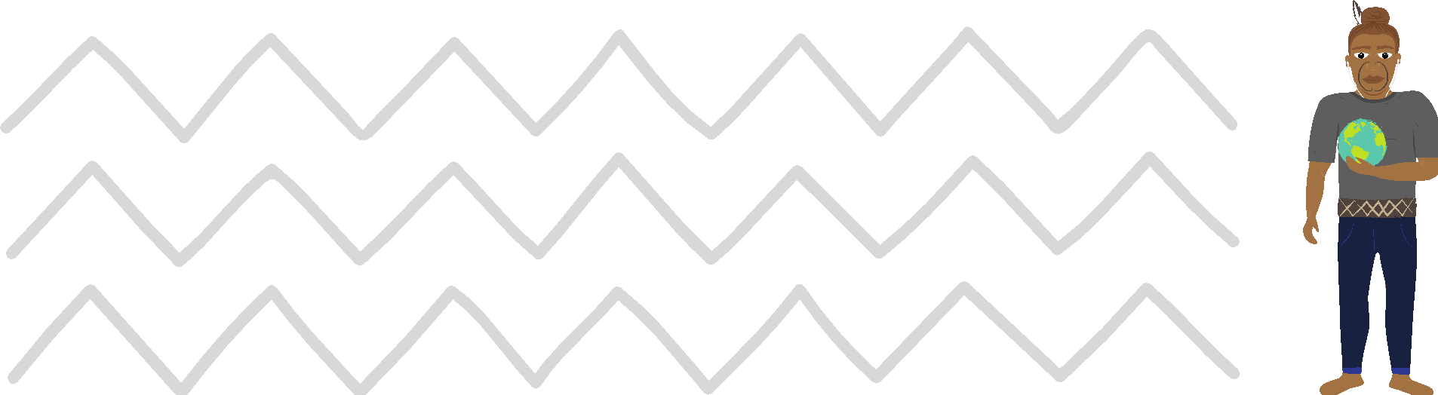

Māui Ātea Te Ngohe Haumitanga 2
Taonga Tuku Iho
I tēnei ngohe ka mārama ake ngā ākonga ki:
- ngā haumitanga ā-iwi i mua i te hainatanga o te Tiriti o Waitangi i te tau 1840
- ngā haumitanga ā-iwi o nāianei – Ngā whakataunga mā te Tiriti o Waitangi

Māu hoki e:
- uru ki ngā matapakinga ā-rōpū
- whakahaere tētahi pakirehua e pā ana ki ngā haumitanga ā-iwi kua oti
kē te whai
- whakaatu ō kitenga

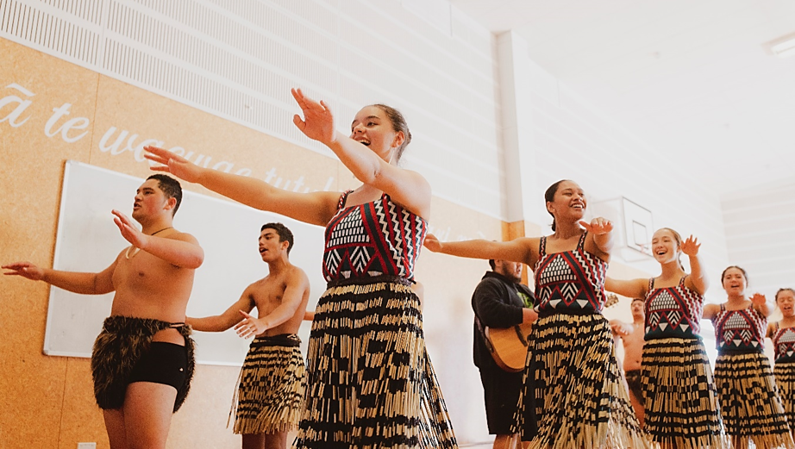

1. Me matapaki ā-rōpū ngā kōrero e whai ake ana
(kia 3-4 tāngata ki ia rōpū):
I nui te haumi a ō tātou tūpuna ki te whakapapa me te manaakitanga o te whenua mā te penapena i ngā mātauranga Māori me te whakamahi rautaki e tika ana kia whai hua ai aua haumitanga. Ko ngā hea i whakahaerehia i roto i ngā ārahitanga o ngā rangatira ā-iwi me ngā tukanga whakatau take.
I whakatauhia te mana o te rangatira me ōna tāngata i runga i tana āhei ki
te penapena, te haumi, te whakaputa me te whakahaere i ngā rawa i whai pānga
ki te whakapapa me te whenua. Ko te ora, te hauora me te tupu ētahi āhuatanga
i kīia he hua nui. Mēnā i tika te whakahaerehia o te whenua me te whakapapa ka tika hoki te ora o te tangata.
He ōhanga ā ngā hapū me ngā iwi Māori i mua i te nōhia o te whenua e tauiwi me
te hainatanga o Te Tiriti o Waitangi. Ko te rahinga o ngā hua i pahawa i ngā mahi ahuwhenua; i te mahinga waitai, waimāori hoki; i te aru me te kohi kai; i te whakairo me ngā mahi o te whare pora; i te hanga i ngā rākau a Tū, i ngā taputapu hanga hoki. Ehara te moni i te aronga o ngā haumitanga nei. Engari kē ko te mana, te aroha, te kotahitanga, te manaaki, te tiaki, te penapena kai mō te hōtoke, te aha atu.

2. Te whakahaere i tētahi pakirehua e pā ana ki ngā haumitanga
ā-iwi kua oti kē te whai
I mua i te hainatanga o Te Tiriti o Waitangi, 1840:
- He aha ngā tūmomo hua i puta i ngā haumitanga ki te whenua me te whakapapa i whakawhiwhia ki tō iwi? Me rangiwhāwhā te titiro me te rapu kōrero i ngā waiata tawhito, ngā pūrākau, ngā maunga, ngā awa, me te aha atu.
- I pēhea te whai take o ngā rangatira me ōna uri ki te whakahaere i ngā hua i ngā haumitanga ā-whenua, ā-whakapapa hoki? Me whānui te whakaaro ki ngā pepeha o te takiwā, ki ngā whakataukī me ngā whakatauākī, ki ngā ingoa hoki o ngā tūtohu whenua o te takiwā.

I muri mai i te hainatanga o Te Tiriti o Waitangi, 1840 ā mohoa nei:
- I hainatia te Tiriti o Waitangi e tō iwi? Nā wai i haina, ā, i hea hoki?
- Kei te pēhea te ora o aua haumitanga ā-iwi i tēnei rā tonu? Me rangiwhāwhā te titiro ki te ora o te reo Māori me ōna tikanga, ngā tauanga hauora o ngā tāngata Māori, ngā tauanga mauhere, me ngā tauanga mātauranga.
3. Whakaaturia ō kitenga
Whakaaturia ō kitenga ki te akomanga. Me whakamahi i ngā atahanga me ngā tauira e hāngai ana. Pōhiritia ō hoa ki te arotake mā te akiaki i a rātou ki te tuku pātai. Whakahaerehia ngā matapakinga ā-akomanga e pā ana ki ngā tauira o ngā kitenga e whakaaturia ana.

He honongaitua:
https://www.govt.nz/organisations/te-kahui-whakatau-treaty-settlements/

