Māui Mataara me te Inihua

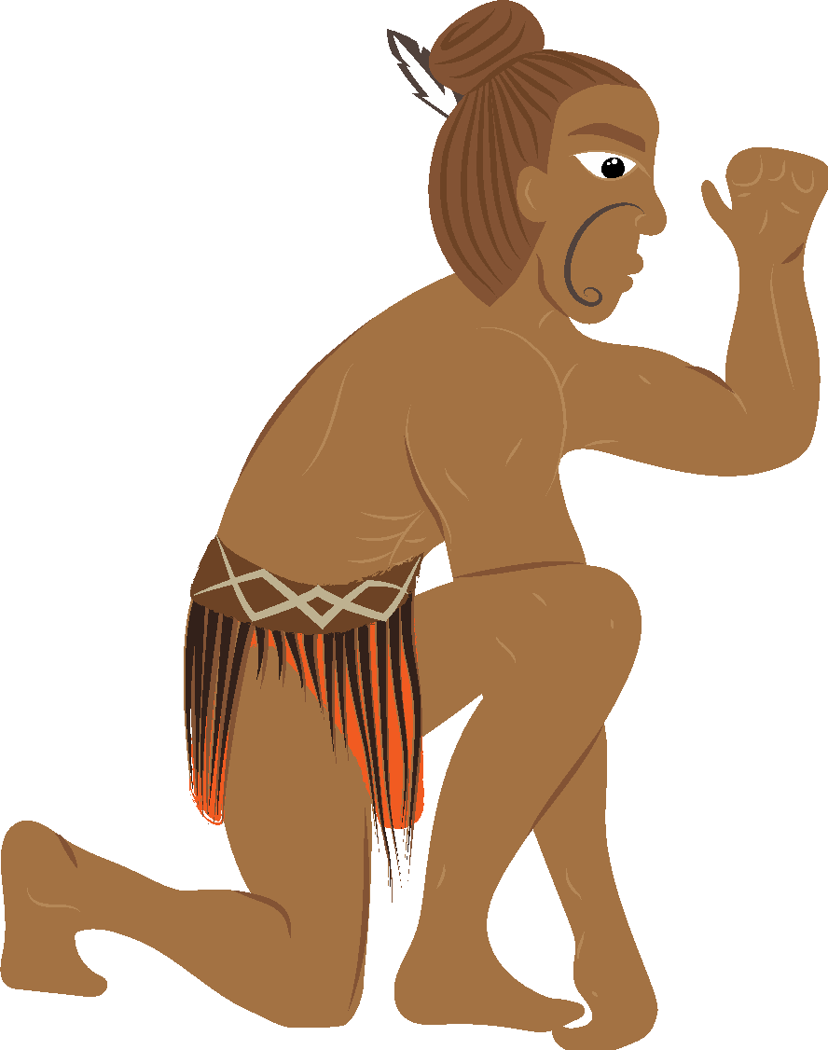
‘Haumarutia tō anamata’
He ohiti, he mataara, he tangata whakatātare, he mātai tonu.

He Kupu Whakataki
Kei te matapakia i tēnei hōtaka ako me te ako a Māui me āna mahi pūkenga hautoa,
me ngā āhua e pāhono ai aua mahi ki te inihua. He āwhina tēnei i tō mārama ki te inihua, ā, ka whakarato kōwhiringa hei whai whakaarotanga māu i a koe e whakamahere ana i tōu anamata.
I tēnei hōtaka, e 3 ngā ngohe;
- Ngohe Inihua 1: He ōrite te waiwai o te inihua I tō te puna tūrama ō Māui
- Ngohe Inihua 2: Meingia kia mahi te inihua mōu
- Ngohe Inihua 3: Te Ao Māori
Kōtahi hoki te aromatawai whakawhanake.
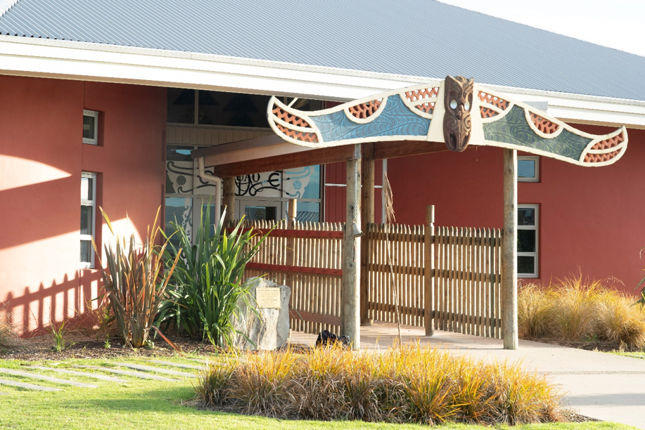
Māui rāua ko Mahuika
I roto i te taukumekume hautoa a Māui rāua ko Mahuika, nā Māui ia i nuka kia tuku ki a ia te ahi mā roto i ētahi momo rākau o te ngahere. Ko te mutunga iho, ka noho te ahi hei takoha ki te tangata. I āta mōhio a Māui ko te tangata e āhei ana te whakahaere i te ahi, ka taea e ia te noho mahana tonu, ā, i a ia te tūrama hei whakakore i te taipōuri.
Nā te hoatu i te whakahaere ahi ki te tangata, i taea e te tangata te noho mahana me te haumaru, i a ia hoki te tau o te wairua nā tōna kaha ki te tahu ahi, te hika anō i te ahi i muri i te tineinga. Waihoki, he māhorahora noa te hiahia a te tangata ki te pare i a ia ki ngā tūāhuatanga whakarere. Pērā i a Māui, nāna a ia anō i inihua kei kore i a ia te ahi.
He whakaritenga te inihua, te inihua rānei, i waenga i ngā rōpū e rua, e whakawhitia ai te mōrea o te ngaromanga mai i tētahi rōpū (ko koe tērā, te tangata whai inihua) ki tētahi atu rōpū (te kaiinihua/kamupene). He parenga pūtea kei pā mai he mea ohorere.
Ko te takune nei, ko te whakarato paremata ki te hunga whai inihua mēnā ka pā mai tētahi takahanga, ngaromanga rānei, nā tāna utu i te moni whāngai. Ina whakatau tētahi ki te utu inihua ka utu ia i te moni whāngai ki te whakarite i tētahi kirimana tērā ka pare i te tangata whai inihua. Ka rerekē te utu i runga anō i te mea, ngā mea rānei kua whai inihua. Ka āhei te utu i taua moni whāngai hei utu tōpū, hei utu harangotengote rānei i ia marama/ia rua wiki/ia wiki rānei.

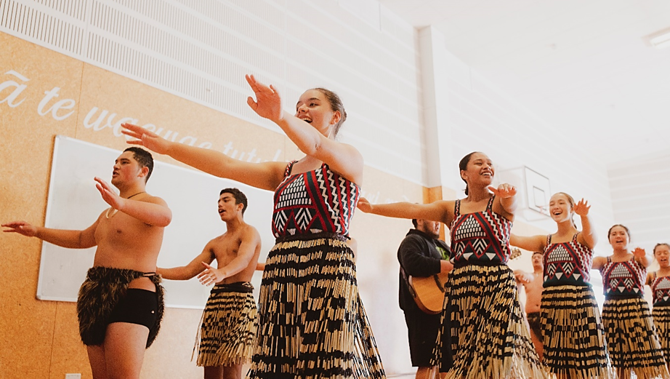

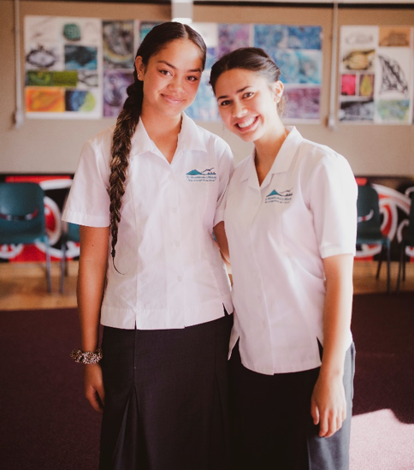
Anei ētahi tino pūtake mo te utu inihua:
- Te pare rawa
- Te pare i te whiwhinga mahi
- Te pare i te mōkete
- Te toha moni ki tō whānau ā muri
i tō matenga
- Te utu utunga hauora mēnā ka
māuiui koe
Kāore he herenga ā-ture i Aotearoa kia whai inihua koe, engari he nuka haumaru kē ka āwhina i a koe ki te whakaora anō mēnā he ngaromanga tōu ka whai pānga ki; ō rawa, tō oranga, ō whanaunga aroha, tō moni whiwhi, tō pakihi hoki/rānei. Ka kitea hoki te inihua hei momo parenga mōu anō, mō tō whānau, ō hapū me ō iwi. He momo pare i a tātou anō te inihua, i ō tātou whanaunga aroha, me ā tātou taonga marihi.
Ahakoa me utu e koe te inihua, ka tau ānō tō wairua i tō māramatanga ki te uara o te whakakapi i tērā i ngaro i a koe. Ka kitea anō te inihua hei parenga ki tō haumi.
Mā te katoa o ēnei e whakatau te momo inihua e tino pai ana māu. He maha ngā momo inihua e wātea ana. Ahakoa ehara te inihua i te kōwhiringa māu i tēnei wā, me āta whai whakaaro ki te momo inihua me te kaihoko inihua e tino pai ana māu. Me tirotiro haere.
Ka āhei te tīmata, te whakamutu rānei i te inihua, e ai ki ō āhuatanga. Me mōhio anō hoki ka kawea he paku mōrea i ngā āhuatanga e kore ai e ōrite te uara inihua ki tō te whakakapi.
Mā te āta mārama ki tēnei mea te inihua, ōna painga me ōna utunga, e āwhina ō whakataunga pūtea mō anamata. Ka whai wāhi tēnei ki te oranga o te tangata. Me kī,
i ēnei rā tonu he rite te inihua ki te puna tūrama o Māui.

