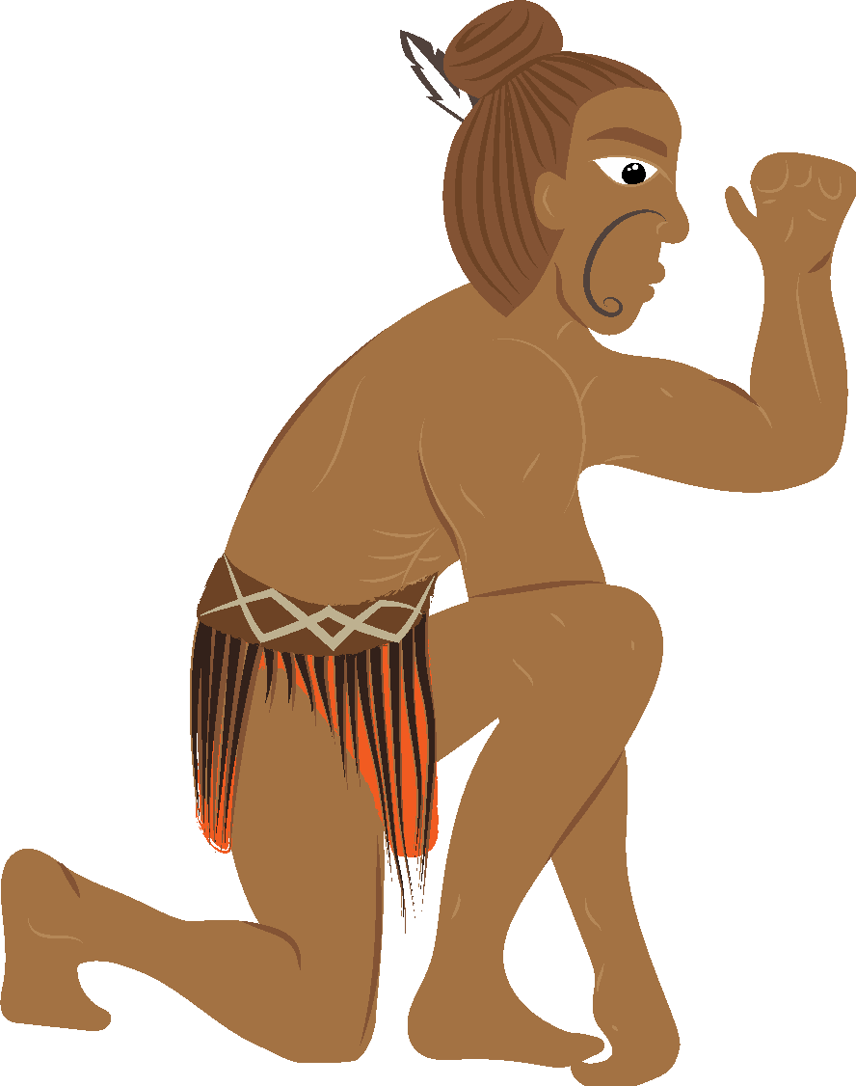

Māui Mataara Ngohe 2: Meingia kia Mahi te Rīanga Mōu
Mā ngā ākonga i tēnei ngohe e:
- mārama ki ngā momo rīanga rerekē e wātea ana i Aotearoa.
- āhei te tautohu i ngā momo rīanga matua e whā hei tīmatanga.
I akona e Māui Mataara i tōna taitamarikitanga te hira o tēnei mea te ahi. I kitea anō ka tūpono noa te poko o te ahi ahakoa he aha te wā, me te aha, ka ngaro mō ake tonu atu. Nā Māui tēnei i rangahau me te aromātai i ngā tūraru. Mutu mai tēnei, ka whakatinana i tētahi mahere.
Te mahere rīanga a Māui
- Ngā momo rīanga
I tētahi mahi tōmua i tautuhia e koe ngā momo rīanga rerekē e hiahiatia ana kia kapi ai ngā tūraru o ia rā. Ko te tauira i whakamahia mō Māui e pā ana ki te whakakapi i tōna paihikara nā te mea i a ia te rīanga taonga.
Kei ngā āhuatanga me ngā waiaro ngā hiahia whai rīanga, tae atu ki:
- tō pakeke
- ō rawa
- mēnā he hiahia tauwhāiti ōu
He maha ngā momo rīanga e wātea ana. Me āta whakaaro ki te momo rīanga me te kaiwhakarato e tino pai ana māu.
Te whakamahere rīanga:
- Me rangahau tuihono ngā momo rīanga e wātea ana i Aotearoa.
  - Whakarārangitia ngā momo rīanga me ngā mea e kapi ai ki roto i te tūtohi e whakaratohia nei i tēnei ngohe.
2. Tautuhia ngā momo rīanga pūnoa i kitea e koe.

Hei Tauira:
I a Māui te rīanga taonga, ka mutu, i āhei te kerēme mō te ngaronga o tōna pahikara.
I whai wāhi tōna pahikara ki tōna rīanga taonga, i kapi hoki hei wāhanga o ana taonga whaiaro. Kei roto i te rīanga taonga ngā mea pēnei i ngā kākahu, ngā rei, ngā taonga
ā-whare, ngā taputapu, ngā mahi toi, me ētahi atu mea e rokirokia ana ki te kāinga.

- Uara o ngā mea e kapi ai i te rīanga
He māmā ake te whai whakaaro ki te uara pea o ngā mea me whai rīanga i te āta whakatau i te uara tuturu. Mēnā kua hokona mai e koe tētahi mea i nā noa nei, mā tētahi rīhiti e hāpono te uara hoko. Ko te tikanga ka heke te uara o ngā mea i roto i te wā. Heoi anō, ka piki kē te uara o ētahi mea, pēnei i ngā mahi toi, i roto i te wā. Ko ētahi atu āhuatanga e rerekē ai te uara rīanga i te uara whakakapi ko ērā pea e nui ake ai te utu whakakapi i te rahi i inihuatia ai.
- He aha ō tino momo rīanga e 4 ka kōwhiri koe hei tīmatanga?
Me whakaraupapa mai i te 1 ki te 4. (1= he whakaarotau - 4 = he hiahia)
  - Momo rīanga
  - Momo Kapi - ka kapi ngā aha?
  - Uara o te/ngā mea e kapi ai i te rīanga

Hei Tauira:
Kua haumi a Māui ki tōna kāinga, ngā taonga o roto, tōna waka me te rīanga tangata. Me whakatau tata a Māui i te uara tapeke o tēnā, o tēnā o aua wāhanga kia āta mōhio ai ka kapi ia mō te ngaromanga, tūkinotanga rānei. E 28 tau te pakeke o Māui, ka whiwhi
i te utu toharite mō ana mahi.

Ngohe 1: Pukamahi Momo Rīanga

Ngā Momo Rīanga | Ngā mea e kapi ai:
Ngā taonga | pahikara, ngā kākahu, ngā rei, ngā taonga ā-whare, ngā taputapu, ngā mahi toi, me ētahi atu mea e rokirokia ana ki te kāinga.

Ngohe 2: Pukamahi Uara

Ngā Momo Rīanga | Ngā mea e kapi ai: | Uara
Ngā taonga  Ka kapi ngā aituā katoa: Waipuke, Weranga, Rūwhenua, Whanakotanga | - pahikara, ngā kākahu, ngā rei, ngā taonga ā-whare, ngā taputapu, ngā mahi toi, me ētahi atu mea e rokirokia ana ki te kāinga.  - Whanakotanga | $60,000.00
1
2
3
4

Ngā honongaitua tautoko:
https://www.aainsurance.co.nz/insurance-calculator/contents-insurance-calculator.html#accordion-groups__Accordion10
https://sumsure.corelogic.co.nz/#/products/8/profiles/211
https://www.westpac.co.nz/insurance/contents/compare/
https://www.westpac.co.nz/assets/Personal/Insurance/JN13883-Your-Contents-Editable-Form_A4-for-web-only.pdf

