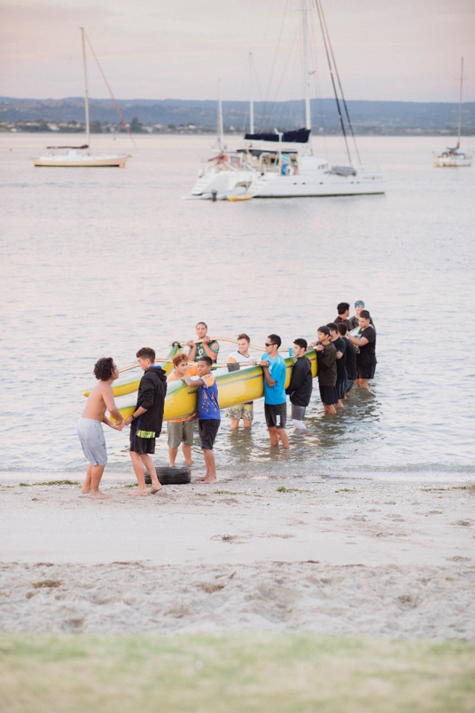
Māui Ihumanea – Te Ngohe Whakatānga 2
He rawaka te rahi o te Pūtea Penihana o Aotearoa mō te whakatānga
Mā ngā ākonga i tēnei ngohe e:
- tautuhi tētahi ritenga Māori taketake e ōrite ana ki te ariā o te whakatānga
- whakamārama haere ki te hira o te whai mahere penapena moni mō te whakatā.

I ngā wā o mua, whakatūria ai he momo mahere whakatānga mō ngā kaumātua. I a rātou e ahungarua ana ka huri haere ā rātou kawenga i te mahi i ngā mahi ā-ringa ki te mahi hei pou herenga mātauranga. Arā, ka noho kē rātou hei kaiatawhai matua mō te hunga tamariki ake, hei kaiako anō hoki mō rātou.
I pau i ngā kaumātua ō rātou oranga katoa ngā whakaakoranga e tika ana te ako, me te whai wheako tērā ka whakawhitia mai anō ki te rangatahi o ngā whānau, mā te tukanga whakawhiti mātauranga i waenga whakatipuranga.
He āhua rite tērā ki tētahi mahere whakatānga e arotahi ana ki te penapena me te haumi moni, engari rawa i aro kē atu ki te whai me te tiaki wheako me te mātauranga. He momo haumi anō ki te whakatipuranga whai ake mā te tiritiri i taua mātauranga ki a rātou. Ahakoa ko te ora o te whānau te take matua, arā kē he ōritenga.
I ēnei rā tonu kitea ai taua ritenga i te maha o ngā whānau. Heoi, he tokomaha ngā kaumātua e whiwhi ana i te Pūtea Penihana o Aotearoa. He penihana tērā e homai ana e te Kāwanatanga o Aotearoa ki ngā tāngata kua eke ki tua o te 65 tau te pakeke. He taupori taipakeke haere te taupori o Aotearoa, me te aha ka uaua haere ake te tohatoha i te Pūtea Penihana o Aotearoa nā te mea e piki tonu ana te tokomaha o ngā tāngata o Aotearoa kua eke ki te tau whakatā i ia tau.
Ko te rahi ka whiwhi te tangata i ia wiki ko te $411. Ki tō whakaaro he nui pea tērā, engari i te ngohe kei raro nei māu e tātai te kounga o te ora mō ētahi o ō tātou kaumātua, i ngā tūāhuatanga ko tēnei tō rātou puna moni whiwhi kotahi.
Te Ngohe 1
He rawaka te rahi o te Pūtea Penihana o Aotearoa mō te whakatānga?
I tēnei ngohe māu e whakaoti te tūtohi i raro me te:
- whakatau mēnā he hiahia me mātua tutuki te utu, mēnā he kōwhiringa noa rānei mō tēnei tangata, i runga anō i te whaiutu
- Me tātai i te pūtea ā-wiki e toe ana, mēnā rā he toenga, mā te tango i te utu whaipainga i te wiki, i ngā utunga rānei mai i te tapeke taumai o te $411

Ka whakautu ai i ngā pātai kei raro i te tūtohi

Mō te taha ki tēnei tangata;
- ka reti i tōna whare noho
- he kaumātua, ka mutu he nui ōna hiahia hauora
- kua whai tāngata i tōna whānau ki te tautoko i a ia
- kua kore e whai motokā, nā tōna kore whai moni hei utu

He rawaka te rahi o te Pūtea Penihana o Aotearoa mō te whakatānga?
Ngā whakapaunga moni ia wiki | Te utu ia wiki  Tapeke whakawaho | 1:  Me utu hei  aha rānei | 2:  $411: Tapeke whakaroto
Riihi | $200 |  | -
Kai | $100 |  | -
Hiko | $40 |  | -
Nga Utu Hauora | $15 |  | -
Waea pūkoro | $10 |  | -
Te tapeke e toe ana ia wiki |  |  | =

Kua takea mai te tūtohi mahere pūtea o runga nei i tētahi kaumātua whakatā e noho ana i Papakura, i Tāmakimakaurau ki te Tonga. Kua tata ki te 80 ōna tau, ā, kua āhua whakatā ia mai i te 65 o ōna tau, me te mahi kōtiwhatiwha i ngā mahi tīpakopako. I ēnei tau e 2 kua pahure ake, e hohe tonu ana ia, engari ka uaua ki a ia ngā mahi ahakoa he mahi hamanga. Heoi anō, e tiaki tonu ana i ana mokopuna, ā, e ai ki a ia ka whakapūhou tonu tērā i a ia.

- Ki tō whakaaro, ko ēhea ngā utu me mātua tutuki, he aha ai hoki?
________________________________________________________________________________________________________________________________________________________________________________________________________________________________________________________________________________________________________________________________________________________________________________________________________________

- Ki tō whakaaro, ko ēhea ngā utu he mea kōwhiringa noa, he aha ai hoki?

________________________________________________________________________________________________________________________________________________________________________________________________________________________________________________________________________________________________________________________________________________________________________________________________________________

- E hia te tapeke e toe ana i ia wiki ki tēnei tangata?

$ _________________

- Ki ō whakaaro, he rawaka tēnei rahinga mō ērā atu utunga ka tūpono mai? Tēnā whakamāramahia mai.

________________________________________________________________________________________________________________________________________________________________________________________________________________________________________________________________________________________________________________________________________________________________________________________________________________

