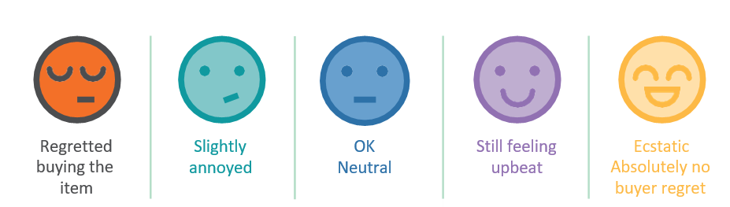
My Spending Diary
Keep your spending diary over a one-week
period or keep it for someone in your household
Analyse your spending habits
- Classify your spending during the week. Did you buy mainly needs, or wants?
- What was your average spend?
- Look at your emoji responses immediately after purchasing.
- Did you make any purchases you immediately regretted? Why?
- Did you make any purchases you felt neutral about? Why did you feel like this?
- Did you make any purchases you felt thrilled about? Explain why you felt thrilled.
- List the factors that influenced your purchases.

After a week, repeat your emoji responses. Have your feelings changed?
- Did any of your responses change?
- If so, can you explain why you think this is?
- Can you analyse your financial identity from any of the results from your spending diary?
- Evaluate any changes you could make on your future spending.
- Record the ways keeping a spending diary helps you to manage debt, goals, and save.

Date | Item | Need/Want | How did you feel immediately after buying the item? | Wk1 | Wk2 | Wk1 | Wk2 | Wk1 | Wk2 | Wk1 | Wk2 | Wk1 | Wk2

